Name: _________________________________________________ Date: ______________
Right Triangle Trigonometry Notes
Name of Function | Abbreviation | Definition

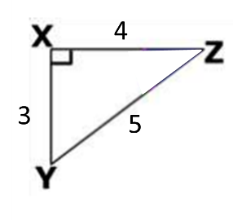
1. 2.

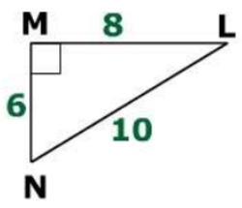
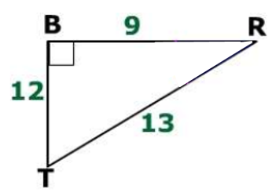
3. 4.

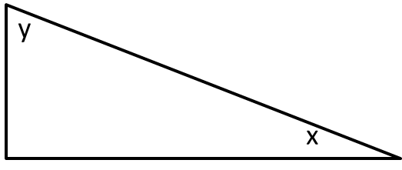
5.

6.

Error Analysis:

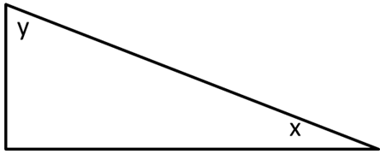
Exit Ticket:

