Name: ________________________________________ Date: _____________________
Right Triangle Trigonometric Ratios
1. 2.

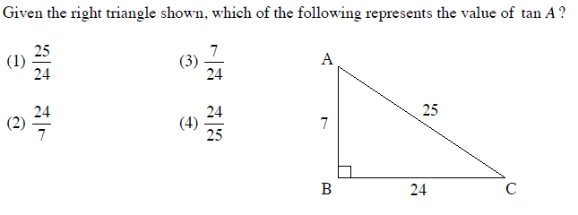
3.

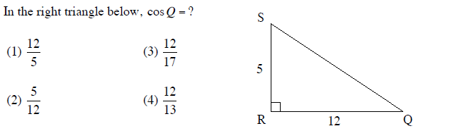
4.

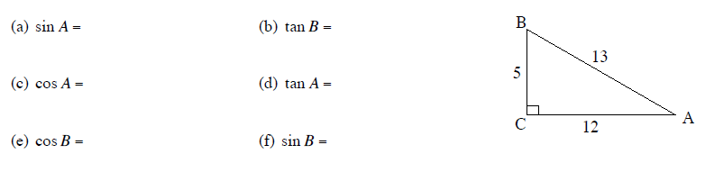
5. Given that sin B = $\frac{12}{20}$

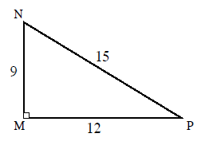
6. Given that tan P =$\frac{9}{12}$ find the following:
(a) cos N = (b) sin N =
(c) tan N = (d) sin P =
(e) cos P =

7. Given sin x = $\frac{1}{3}$ , find cos x.

8. Given cos y = $\frac{4}{7}$ , find tan y.

