Name _______________________________________ Date _____________________

Segment Addition Postulate and Pythagorean Theorem Worksheet

- Write out the segment addition postulate for the following diagram:
C
A
T

- If AB = 27 and BC = 13, find the length of AC. 3. If TD = 32 and YD = 51, find YT
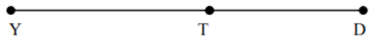

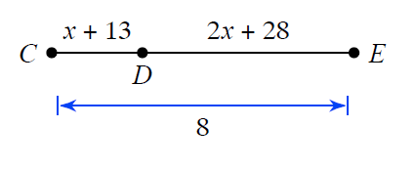
For the following problems solve for the value of x. Then use x to find the measures of all three line segments.
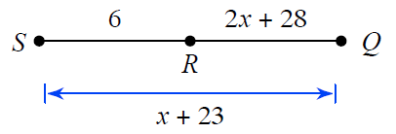
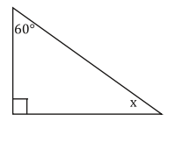
4. 5.

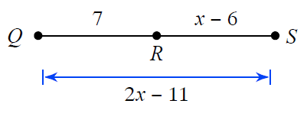
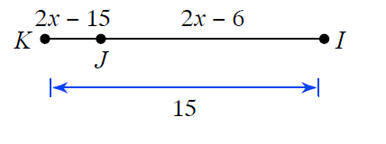
6. 7.

GET WORKSHEET FROM LET’s PRACTICE GEOMETRY
http://www.letspracticegeometry.com/wp-content/uploads/2011/11/pythagorean-theorem.pdf

