Name: ____________________________________________________ Date: ________
Series of Transformations Project
- Create your own shape using a minimum of five points. Graph and label your pre-image.
- Now you have to apply four transformations to your shape.
  - One translation
  - One reflection
  - One rotation
  - One dilation
- You must write them out in the order you do them and write down the rule that was used for each.
  - Translate (x,y) (x+30, y-36)
  - Reflect across the line y=-40
  - Rotate 180° counterclockwise
  - Dilation $k=50$
- Color or trace each shape in a different color.
- Make sure you are listing the coordinates for all of your points in all of the shapes.
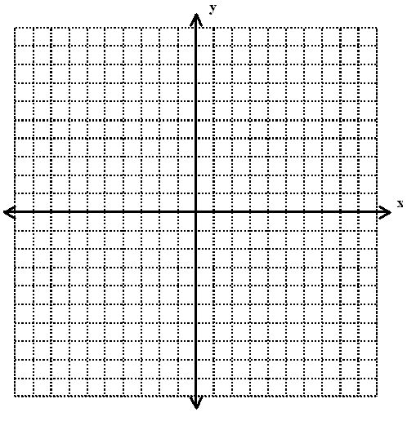
- Make sure you are labeling all points on your graph.

Translate
(x,y) (x,y)
Reflect
Line of Reflection
Rotate
Degrees & direction
Dilation
$$k=$$

