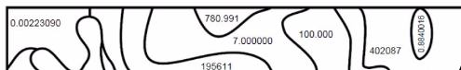
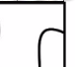
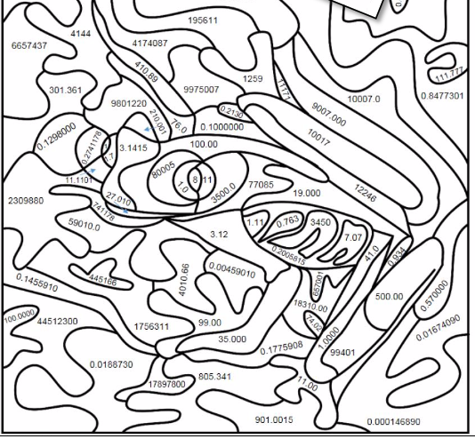
Rules: Color each part of the picture below according to the correct number of significant figures.

