Name: ___________________________________________________ Date: ______________________

Similar Right Triangles Notes

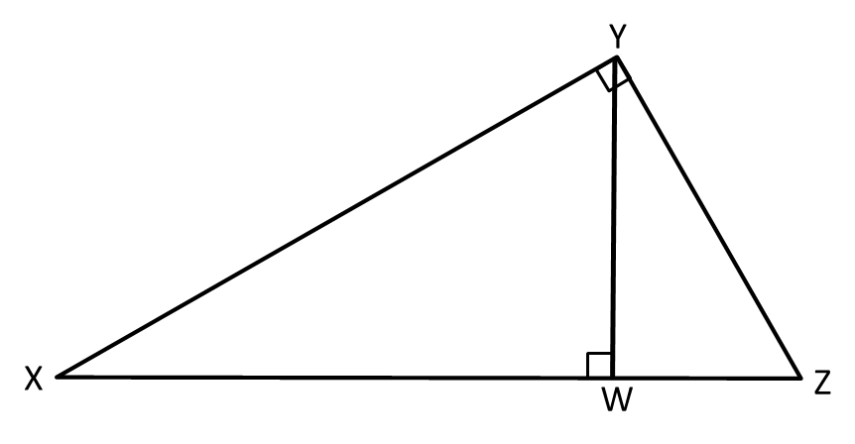Warm Up: Name all the angles shown in the diagram.

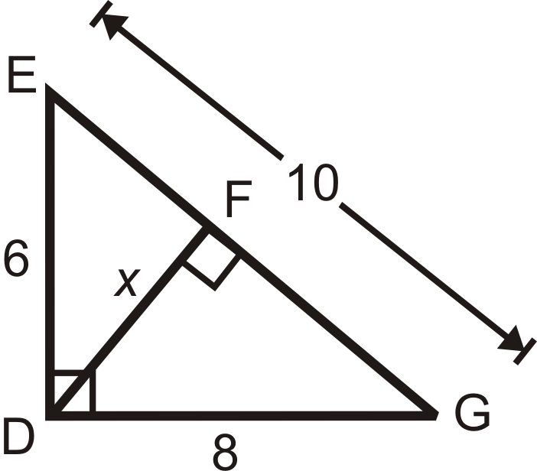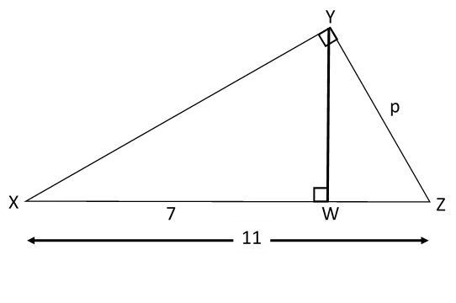

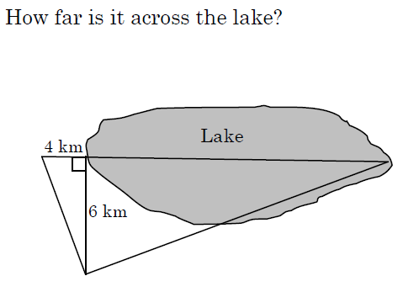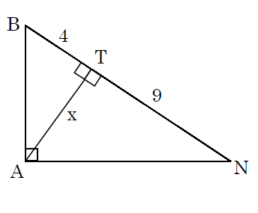How far is it across the lake?

You and some friends decide to go camping. The first thing you do is set up a pole at S. After setting up the pole, you walk 6 steps to point P and put a stake in the ground. From point P, you walk 30 paces to point R and put another stake in the ground. How tall is the pole?

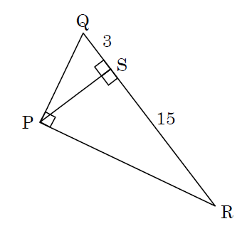 Exit Ticket:

