Name: _______________________________________________________ Date: __________________
Similar Right Triangles Notes 2
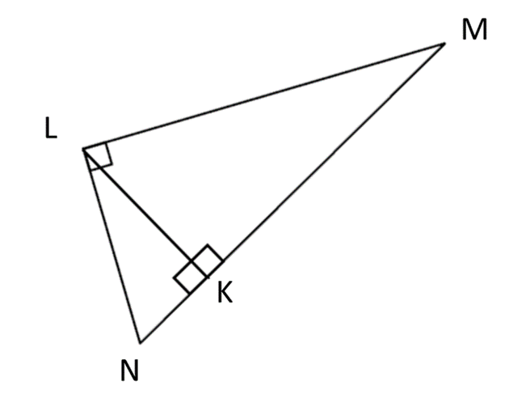
Warm up: Identify the three similar triangles.

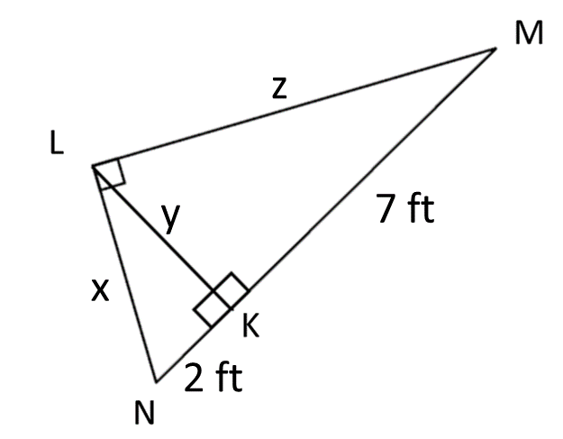

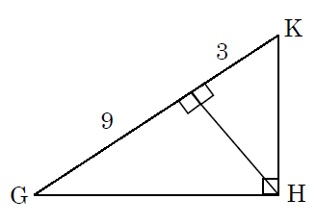

The figure shows the side view of a tool shed. What is the height of the roof?
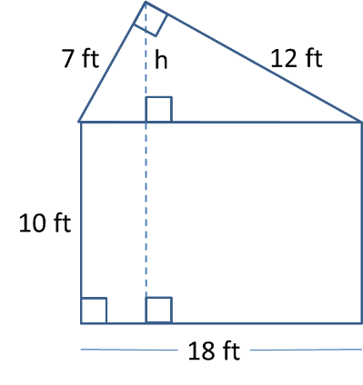

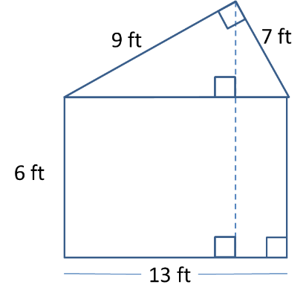
The figure shows the side view of a tool shed. What is the height of the shed?

Exit Ticket:
