Name: _________________________________________________ Date: ______________
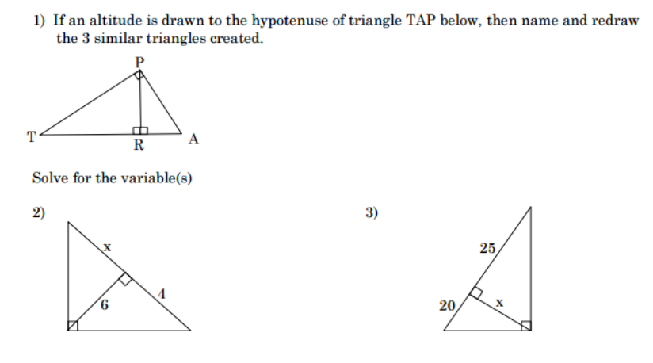
Similar Right Triangles Worksheet

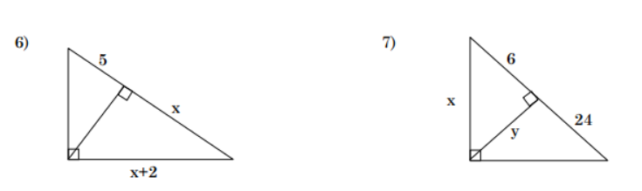
7

30

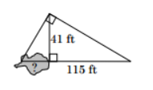
8. How far is it across the quicksand?

9. The altitude of a right triangle divides the hypotenuse into two segments whose lengths are 9 cm and 16 cm ($\overline{AR}$ and $\overline{TR}$). Find the lengths of the two legs. ($\overline{AP}$ and $\overline{TP}$).

10. Find the lengths of GH and HK.
