Notesnotesnotesnotesnotesnotesnotesnotesnotesnotesnotesnotesnotesnotesnotesnotesnotesnotesnot
Name: ______________________________________________ Date: _______________
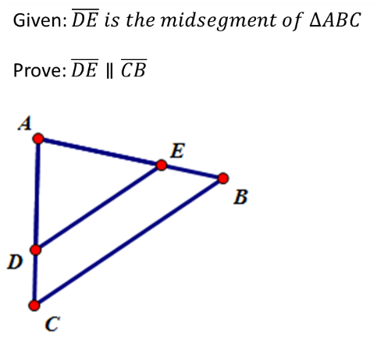
Similarity Proofs & Properties Notes
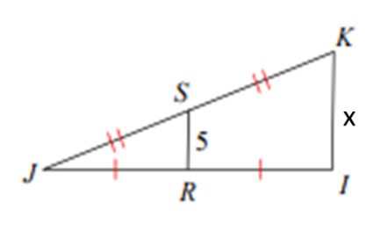

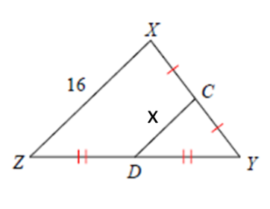

Notesnotesnotesnotesnotesnotesnotesnotesnotesnotesnotesnotesnotesnotesnotesnotesnotesnotesnot
Name: ______________________________________________ Date: _______________
Similarity Proofs & Properties Notes

