Name: __________________________________________________ Date: ______________________

Similarity Proofs & Properties Worksheet

For numbers 1-6 set up and solve an equation to find the value of

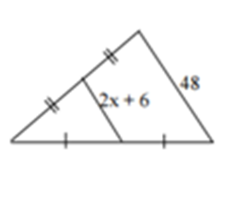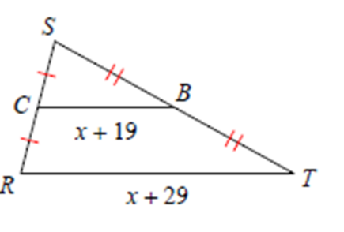

1. 2.

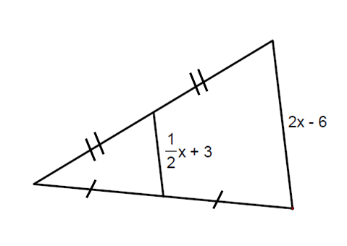

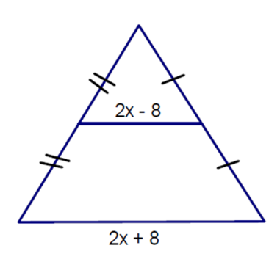

3. 4.

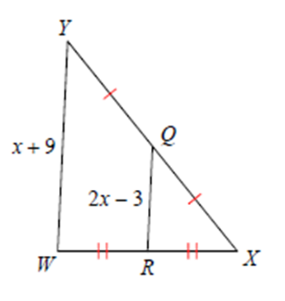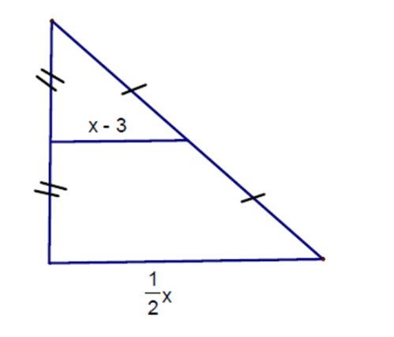

5. 6.

7. Given

Prove:

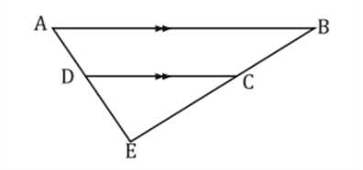

8. Given: ;

Prove:

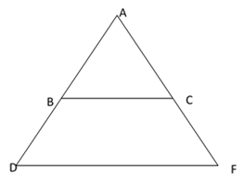

9. Given: ;

∠A ≅ ∠D

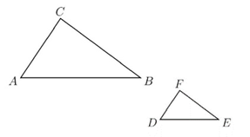Prove:

10. Given: is the midsegment of $∆OMQ$

Prove:

