Notesnotesnotesnotesnotesnotesnotesnotesnotesnotesnotesnotesnotesnotesnotesnotesnotesnotes
Name: __________________________________________ Date: _____________________
Similarity Proofs Notes Day 3
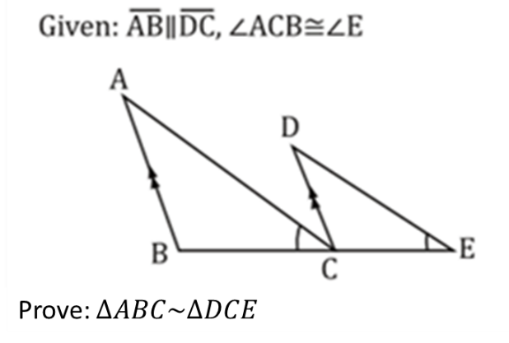

Notesnotesnotesnotesnotesnotesnotesnotesnotesnotesnotesnotesnotesnotesnotesnotesnotesnotes
Name: __________________________________________ Date: _____________________
Similarity Proofs Notes Day 3

