Notesnotesnotesnotesnotesnotesnotesnotesnotesnotesnotesnotesnotesnotesnotesnotesnotesnotes
Name: _____________________________________________ Date: _______________________
Similarity Proofs Notes Day 1
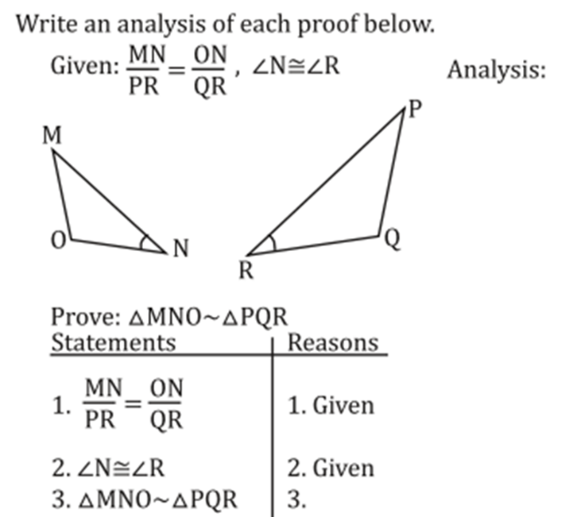
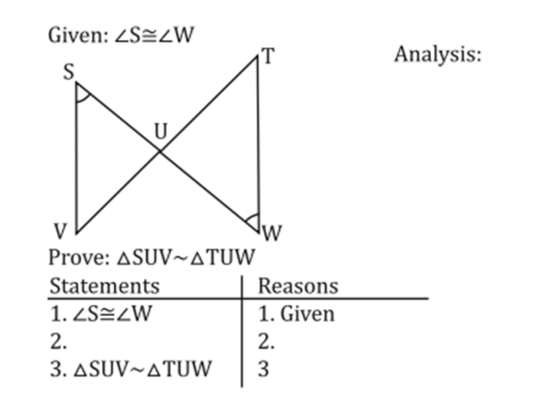

Analysis: Analysis:

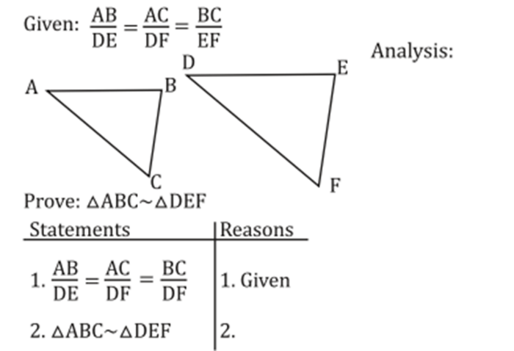
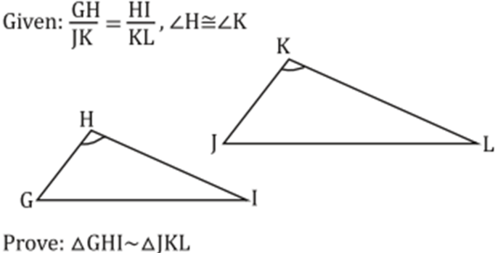

Analysis:

