Name: _____________________________________ Date: _____________________

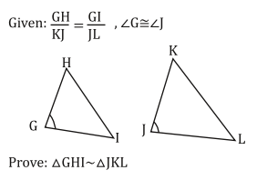Similar Triangles Proofs: Worksheet

1. 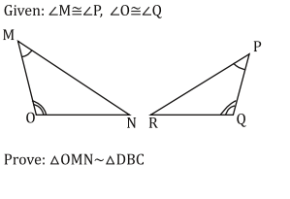
2. 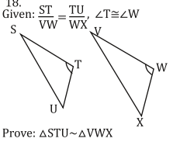
4. 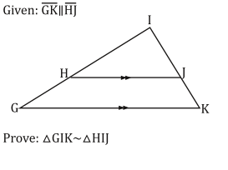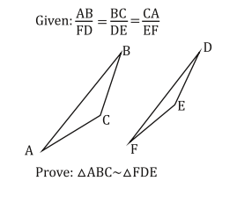
5. 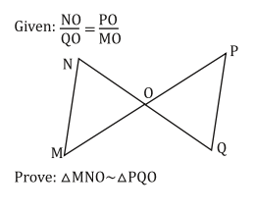
6. 