Given: $\overline{MQ}∥\overline{OP}$  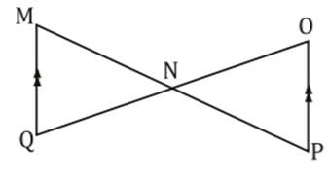  Prove: $∆MNQ\sim ∆PNO$ | Given: $AB=1 ;AD=6$  $AC=2 ;AF=12$  Prove: $∠ABC≅∠D$  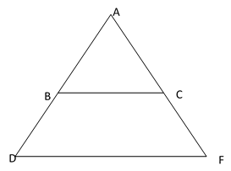 | Given: $\overline{HJ}∥\overline{GK}$  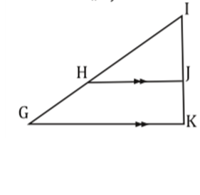  Prove: $\frac{IJ}{IK}=\frac{IH}{HG}$
Given: $AB=2 ;PQ=6$  $AC=5 ;PR=15$  $∠A≅∠P$  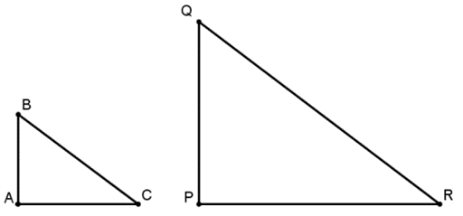  Prove: $∆ABC\sim ∆PGR$ | Given: $\overline{BA}∥\overline{CD}$  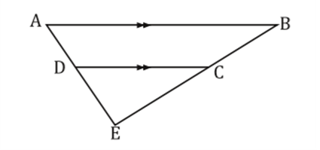  Prove: $\frac{AB}{DC}=\frac{AE}{DE}$ | Given: B is the midpoint of$\overline{AD}$  C is the midpoint of$\overline{AF}$  Prove: $∠ACB≅∠F$
Given: $\overline{BC}$ is the midsegment of $∆ADF$  Prove: $\overline{BC}∥\overline{DF}$  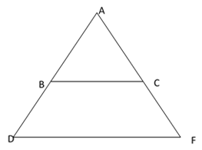 | Given: $\overline{BD}∥\overline{AE}$  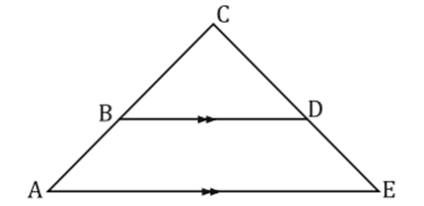  Prove: $∆CBD\sim ∆CAE$ | Given: $AE=2 ;ED=6$  $BC=4 ;BD=16$  Prove: $∠DEC≅∠A$  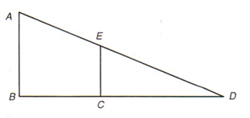
Tic-Tac-Toe Proofs
Directions: Complete any three proofs to form Tic-Tac-Toe!
Write your proofs on a separate sheet of paper and staple together before turning in.
Tic-Tac-Toe Proofs
Directions: Complete any three proofs to form Tic-Tac-Toe!
Write your proofs on a separate sheet of paper and staple together before turning in.
Given: $\overline{AB}∥\overline{DC}$  Prove: $∆EDC\sim ∆EAB$ | Given: $AE=7 ;ED=14$  $BC=8 ;BD=24$  Prove: $∆EDC\sim ∆ADB$  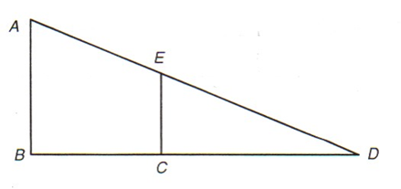 | Given: T is the midpoint of$\overline{US}$  V is the midpoint of$\overline{UW}$  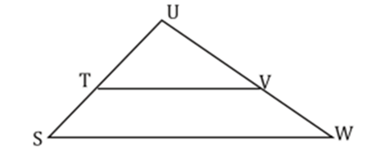  Prove: $\overline{TV}∥ \overline{SW}$
Given: $UT=3 ;US=15$  $UV=4 ;VW=16$  Prove: $∆UTV\sim ∆USW$  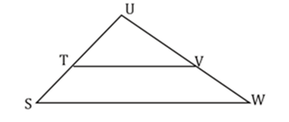 | Given: $\overline{MP}$ is the midsegment of $∆RNQ$  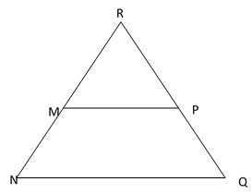  Prove: $\overline{MP}∥ \overline{NQ}$ | Given: $\overline{NP}∥\overline{MQ}$  Prove: $∆ONP\sim ∆OMQ$  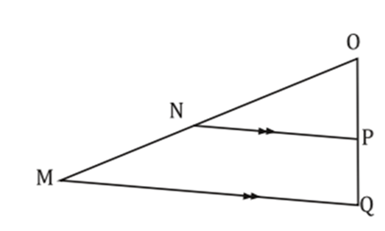
Given: E is the midpoint of$\overline{AD}$  C is the midpoint of$\overline{BD}$  Prove: $\overline{EC}∥ \overline{AB}$ | Given: $\overline{AB}∥\overline{CD}$  $∠B≅∠D$  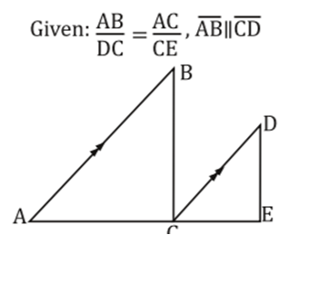  Prove: $∠BCA≅∠E$ | Given: $AC=10 ;DF=2$  $AB=15 ;DE=3$  ∠A ≅ ∠D  Prove: $∆ACB\sim ∆DFE$  