Para Calentarnos: Conjugate the following verbs.
Contestar – to answer
Yo |  | Nosotros(as)
Tú |  | Vosotros(as)
Él, Ella, Usted |  | Ellos, Ellas, Ustedes

Desayunar – to eat breakfast
Yo |  | Nosotros(as)
Tú |  | Vosotros(as)
Él, Ella, Usted |  | Ellos, Ellas, Ustedes

Cenar – to eat dinner
Yo |  | Nosotros(as)
Tú |  | Vosotros(as)
Él, Ella, Usted |  | Ellos, Ellas, Ustedes

Yo _______________________ a las siete de la mañana. (desaynar)
Tú y yo ______________________ en el restuarante. (cenar)
Elena _____________________ al parque con Dennis. (caminar)
Ale y Mónica ___________________ a la officina. (andar)

Classwork: Review the Gramática p106: Making Introductions: te, le, les. Complete p105 Te presento a mi amigo. Complete p106 ¿Quiéns son? (Write out) Review the Gramática p107: Using Contractions: al, del. Complete p107 ¿Adónde vas? (write out) Complete p107 De visita en la ciudad.
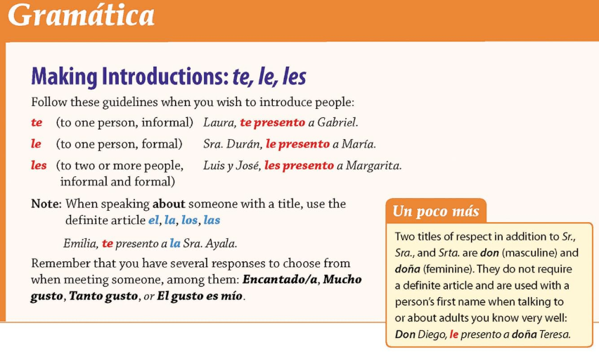
*Remember: te, le, and les refer to the person in which you are speaking to. Don and Doña are terms of endearment and are thereby informal.
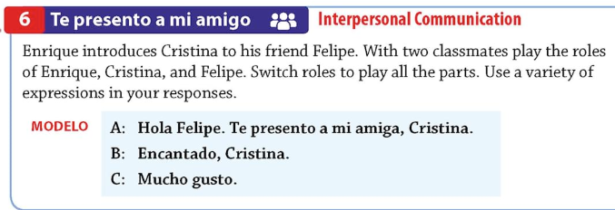
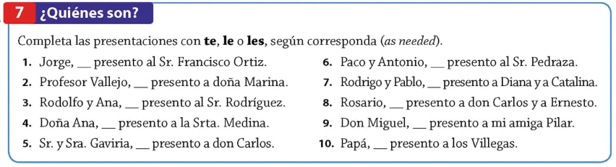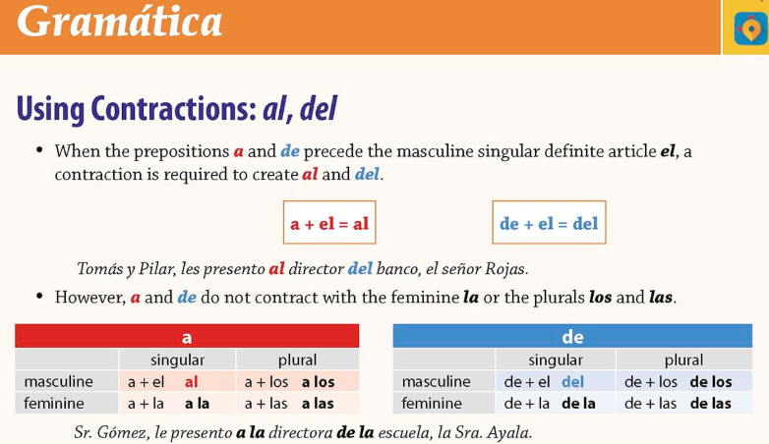
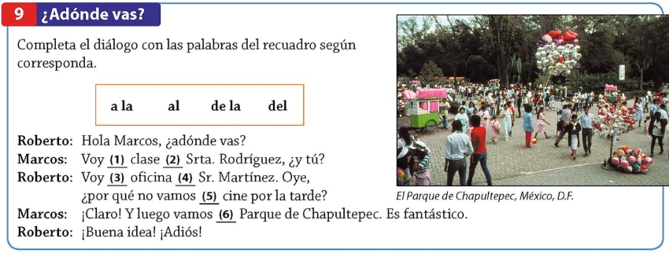
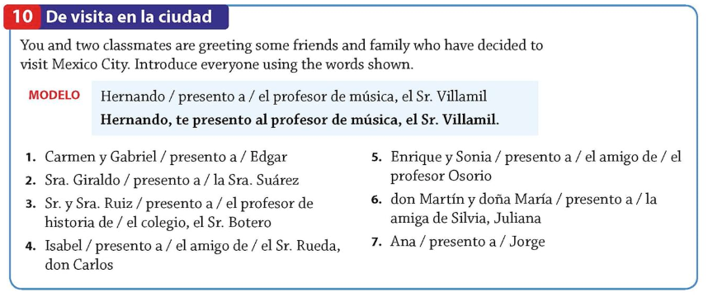
Classwork: Review p108 Repaso rápido, Question Words (Palabras Interrogativas) Review p109 Gramática: Asking Questions: Ways to Form Questions. Complete p108 Es una fiesta fantástica.
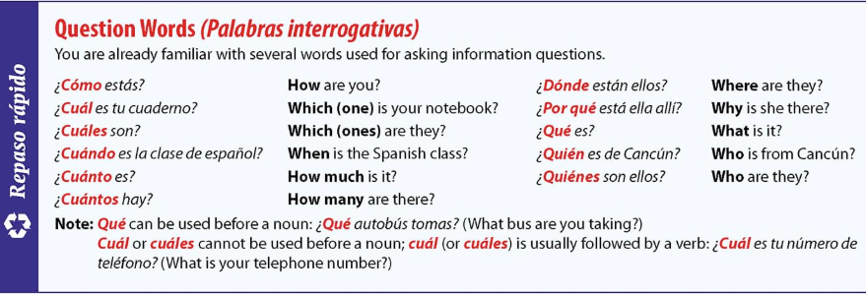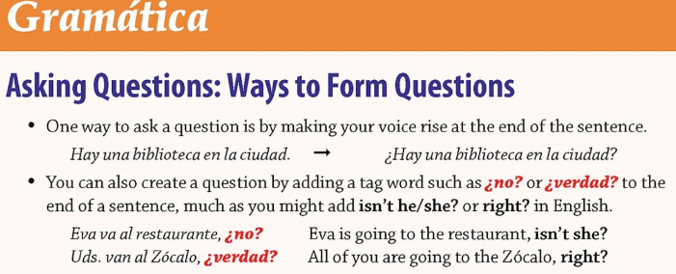

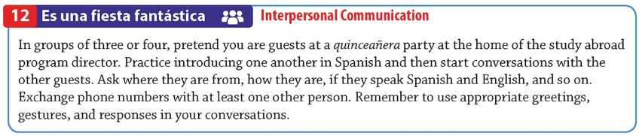
Make sure to contestar all of the questions.
*-*-*-*-*-*-*-*-*-*-*-*-*-*-*-*-*-*-*-*-*-*-*-*-*-*-*-*-*-*-*-*-*-*-*-*-*-*-*-*-*-*
Es la quinceañera de __________________________________.
Cuál es el nombre del director?
___________________________________________________________________

Person 1:
Person 2:
Person 3:
Person 4:

Check list, your diálogo must include:
Introductions
Where each person is from (Ser)
How each person is doing (Estar)
If they speak Spanish and English (Hablar)
Exchange phone numbers

Classwork: Review p109 Gramática: Asking Questions: Ways to Form Questions. Complete p109 En forma de pregunta. Complete p109 ¿Sí o no? Complete workbooks pages 45-46, Mucho gusto, preguntas, Más preguntas.
