Para Calentarnos: Complete the -ar and -er conjugation pattern.
-AR Verbs | o
-ER Verbs |  | es

Classwork: Complete the packet: Las tres culturas
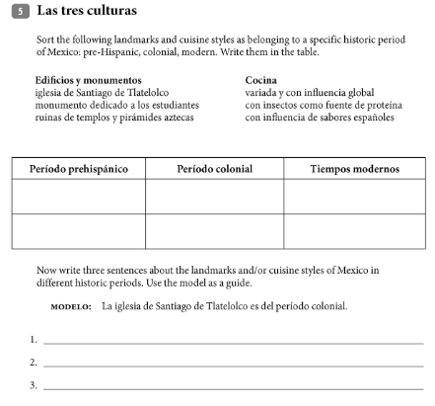
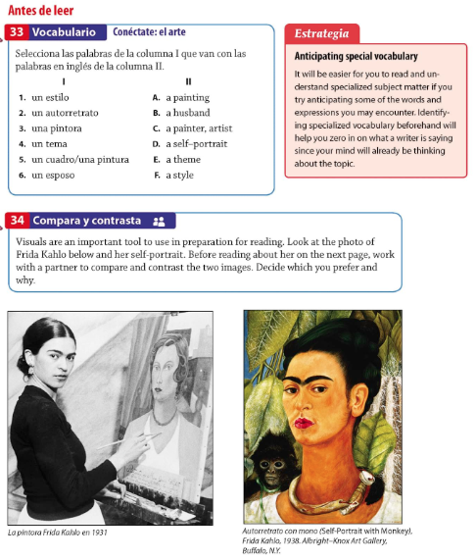
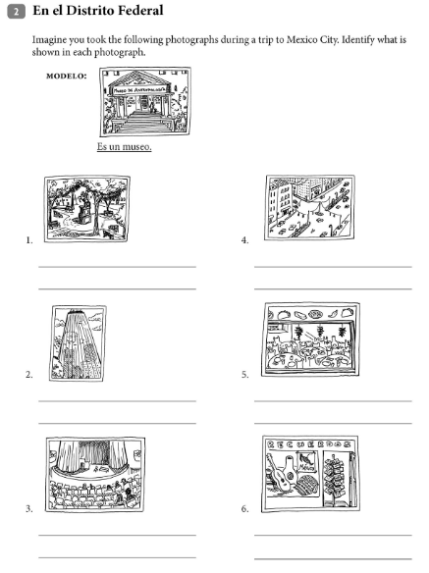
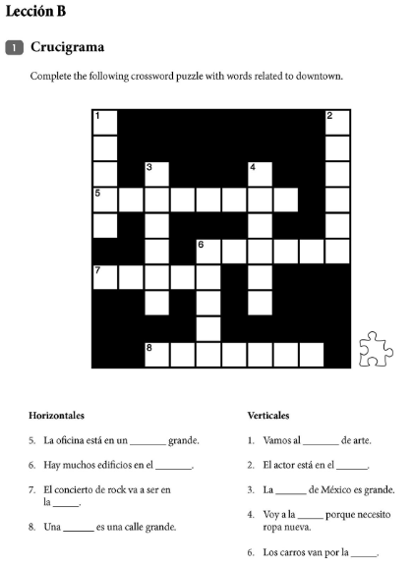
Para Calentarnos: Conjugate the verb Tener.
Tener: to ________________________
Yo |  | Nosotros (as)
Tú |  | Vosotros (as)
Él, Ella, Usted |  | Ellos, Ellas, Ustedes

Classwork: Complete the Writing Prompt.

Writing Prompt
You are the infinitive verb “Tener” known in English as the verb “to have”. In a well written paper, explain your functions in the Spanish language to a non-Spanish speaker.
[1.1 1.3 3.1 4.1 ]
Remember to:
- Tell if you are a regular or an irregular verb.
- Tell of your four different functions
- Give examples of how you act in your different functions
- Tell if you need others or not-subject pronouns, direct object pronouns or reflexive pronouns.

Check your work:
_____The paper is clear, focused and contains relevant ideas.
_____The structure moves the reader purposefully through the piece.
_____The piece is expressive and engaging.
_____The piece is precise, vivid and the language makes the piece extremely clear,
original and memorable.
_____There is an easy flow from one sentence to another.
_____There are varied sentence structure and length.
_____The piece is carefully edited and there aren’t any distractions to confuse the reader.
_____ I have checked spelling, grammar and punctuation.

Please make sure you turn in your draft with your final copy.
¡Gracias!

SCORES
Traits | 5 | 3 | 1
Ideas
Organization
Voice
Word Choice
Sentence Fluency
Conventions

