Nombre ______________________________ Clase: ____________________ Fecha: _________________________
Para Calentarnos: Match the following vocabulary words:
La Familia (Hint: page 150)
 | La familia | A | me
 | mi abuelo/a | B | The family
 | yo | C | my cousin
 | mi hermano/a | D | my grandparent
 | mi primo/a | E | my mother
 | my tío/a | F | my father
 | mi padre | G | my uncle/aunt
 | mi madre | H | my sibling (brother/sister)

Classwork: Review p 150 La familia. Watch “La Familia” video from Discovery and translate lyrics. Students are to complete the chart below stating each person’s family title using self-made questions. Review p 151 Para conversar, para decir más y Un poco más. Complete p 152 ¿Quiénes son? Complete p 152 ¿Cierto o falso? Complete p 152 José y su familia.
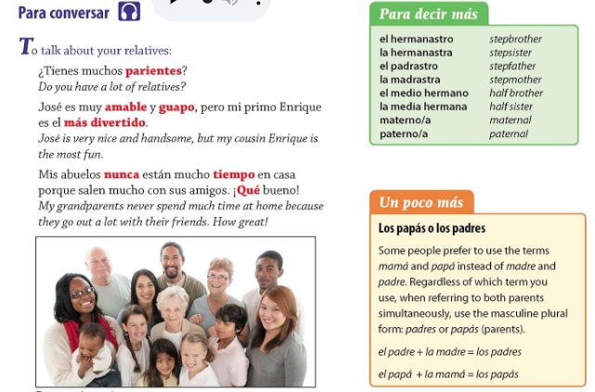
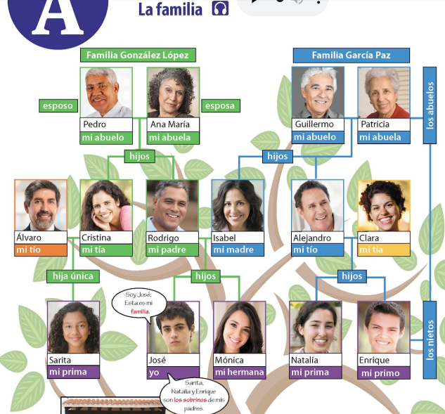
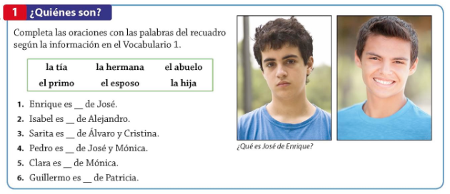
1.
2.
3.
4.
5.
6.

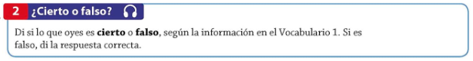
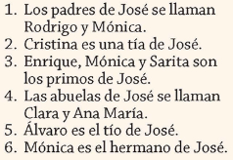
1.
2.
3.
4.
5.
6.

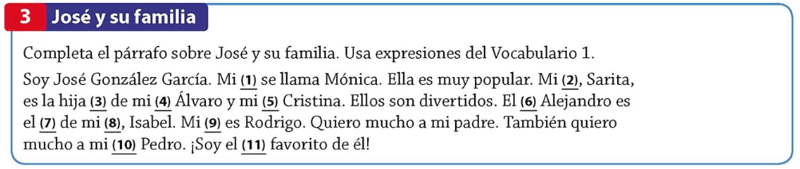

 | Family titles |  | Classmates Names
 | Yo | A
 | madre | B
 | padre | C
 | hermana | D
 | hermano | E
 | abuela | F
 | abuelo | G

Create five questions find out who each person is.
1.
2.
3.
4.
5.

Nombre: _______________________________________ Fecha: _____________________ Clase: ______________
Para Calentarnos: Match the following vocabulary words:
 | amable | A | beautiful
 | bonito/a | B | affectionate
 | cansado/a | C | fun
 | cariñoso/a | D | handsome
 | contento/a | E | nice, kind
 | divertido/a | F | tired
 | guapo/a | G | sad
 | nervioso/a | H | popular
 | popular | I | nervous
 | triste | J | content, happy

Classwork: Translate p 153 Diálogo: En la fiesta del abuelo. Complete p 153 ¿Qué recuerdas? (In complete Spanish sentences.) Complete p 153 Algo personal. Complete p 153 ¿Quién es? (listening) Summarize p 154 Repaso rápido: Adjectives.
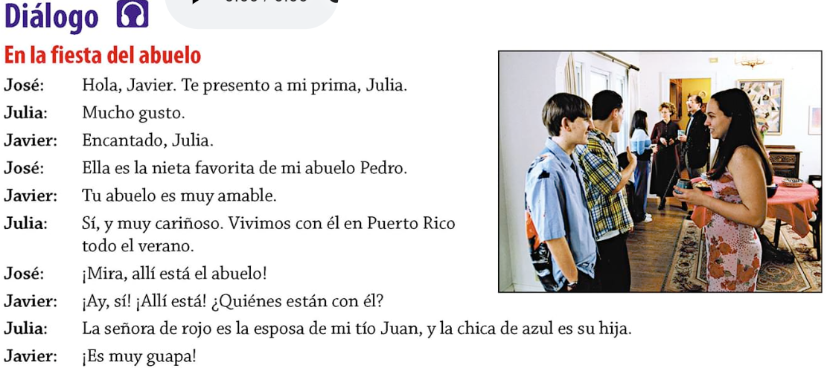
José
Julia
Javier
José
Javier
Julia
José
Javier
Julia
Javier

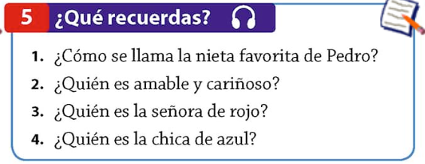
1.
2.
3.
4.
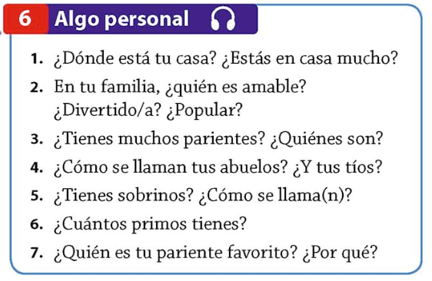
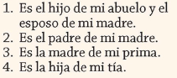
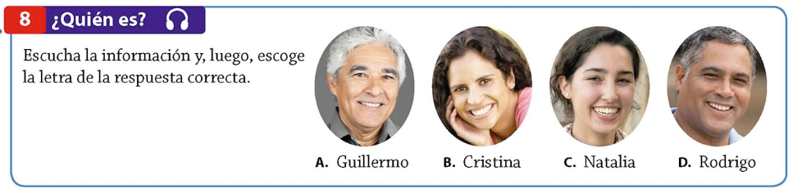

Para Calentarnos: Complete p 154 Mi familia en San Juan
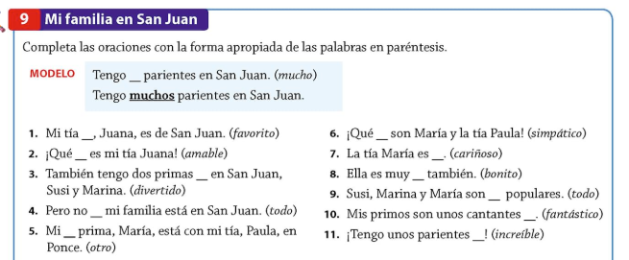
1 | 6
2 | 7
3 | 8
4 | 9
5 | 10
 | 11

Classwork: Watch Possessive Adjectives in Spanish Video from Discovery and complete the “Video: Possessive Adjectives in Spanish” worksheet. Complete Communicative Activies: La familia de Pablo and ¿Cómo están? (in class activity) Complete p 156 Fotos de mis parientes.
Video: Possessive Adjectives in Spanish
Define Adjective: ______________________________________________________________________________________________________________________________________________________________________
Define Possessive Adjective: ______________________________________________________________________________________________________________________________________________________________________
Give an Example of a sentence with a possessive adjective: ___________________________________________________________________________________
What are some possessive adjectives in English? ___________________________________________________________________________________

What are the possessive adjectives in English and Spanish?
English | Spanish

Tener – to have
Yo |  | Nosotros (as)
Tú |  | Vosotros (as)
Él, Ella, Usted |  | Ellos, Ellas, Ustedes

You have to do your homework. ___________________________________________________________________________________
She has to do her homework. ___________________________________________________________________________________
We have to do our homework. ___________________________________________________________________________________
You all have to do your homework. ___________________________________________________________________________________
They have to do their homework. ___________________________________________________________________________________
You have to do my homework. ___________________________________________________________________________________

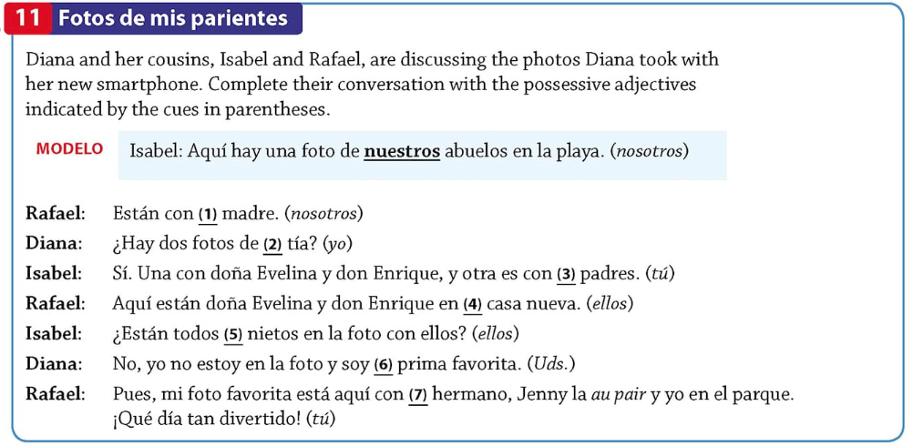
1.
2.
3.
4.
5.
6.
7.
