Para Calentarnos: Match the Subject (Pronoun) with the correct -AR conjugation ending.
 | Yo | A | A
 | Tú | B | AMOS
 | Juilio | C | AS
 | Ella | D | AN
 | Sra. Jean | E | O
 | Nosotros | F | AN
 | Vosotros | G | A
 | Sara, Mia y Carlos | H | ÁIS
 | Maria y Ana | I | A
 | Uds. | J | AN

Classwork: Complete Spanish I SLO on Unify/Performance Matters.
*-*-*-*-*-*-*-*-*-*-*-*-*-*-*-*-*-*-*-*-*-*-*-*-*-*-*-*-*-*-*-*-*-*-*-*-*-*-*-*-*
Para Calentarnos: Complete the following sentences using the correct possessive adjective (mi, tu, su, nuestro, vuestro, su).
1. ¿Dónde está ______ libro de arte? (my) | 3. Vamos a _______________ casa.
2. Tiene que hacer _______ trabajo. | 4. ¿Dónde están _______ llaves?

Classwork: Complete p 156 Fotos de mis parientes. Watch Discovery Video: Review Conjugating Spanish Verbs and Complete Worksheet. Conjugate the verb Salir. Complete p 158 ¿A qué hora salen? Review p 158 Para decir más. Complete p 158 ¿Cómo es tu familia (Write out about 5 family members.)
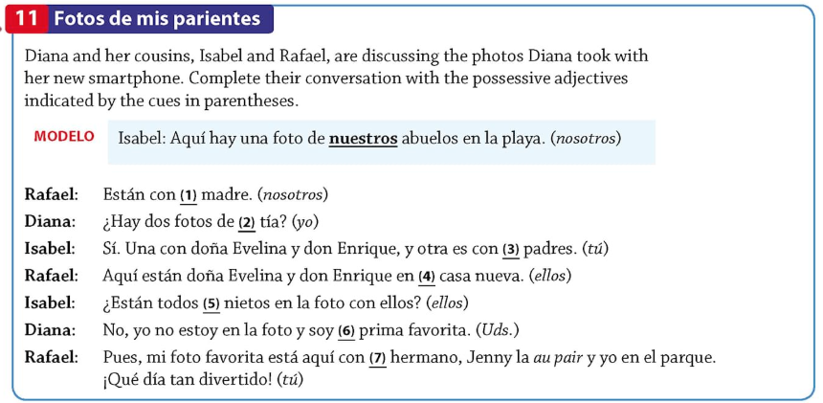
1. | 2. | 3. | 4.
5. | 6. | 7

Video: Review Conjugating Spanish Verbs
What are the 3 types of verbs in Spanish? __________________________________________________________________________________________________
Define “Present Tense”. __________________________________________________________________________________________________
How do you say: We speak Spanish? __________________________________________________________________________________________________
How do you say: I eat tacos? __________________________________________________________________________________________________
Define “Vivir”. __________________________________________________________________________________________________
How do you say: You live in a house? __________________________________________________________________________________________________

Complete the patterns for the verbs.
-AR
Yo | Tú | Él, Ella, Usted | Nosotros/as | Vosotros/as | Ellos, Ellas, Ustedes

-ER
Yo | Tú | Él, Ella, Usted | Nosotros/as | Vosotros/as | Ellos, Ellas, Ustedes

-IR
Yo | Tú | Él, Ella, Usted | Nosotros/as | Vosotros/as | Ellos, Ellas, Ustedes

What are the similarities between -er and -ir?
________________________________________________________________________________________________________________________________________________________________________________________________________________________________________________________________________________________________________________________________________________________________________________________________________
Conjugate the verb: Salir
Salir – to go out / leave
Yo |  | Nosotros/as
Tú |  | Vosotros/as
Él, Ella, Usted |  | Ellos, Ellas, Ustedes

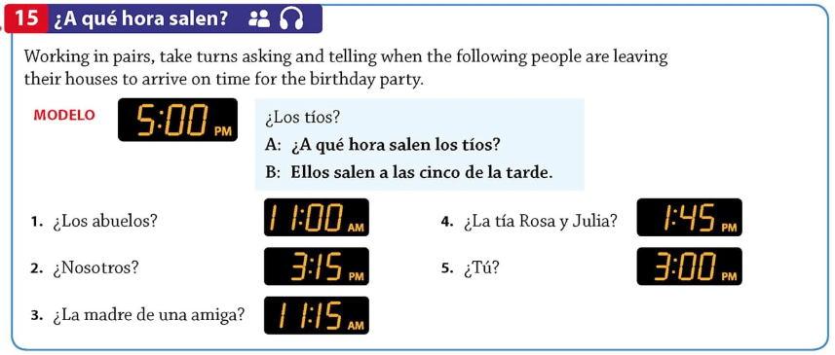
1.
2.
3.
4.
5.
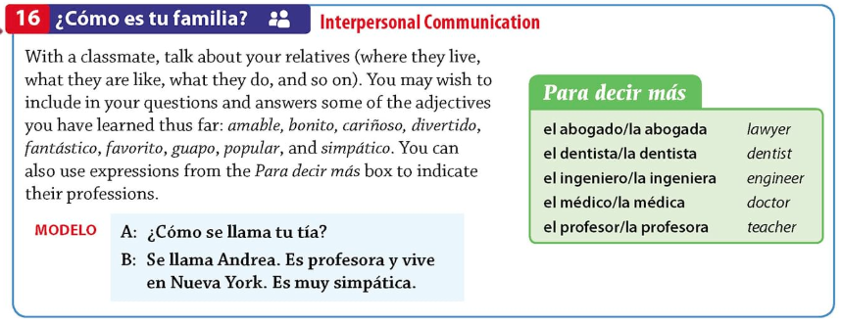
1.
2.
3.
4.
5.

