Translate the following family vocabulary.
English | Spanish
brother
sister
mother
father
cousin female
cousin male
aunt
uncle
grandfather
grandmother
grandchild

Complete the family tree. Your tree can be either non-fiction or fiction. Everyone’s tree need to be different. If your information matches another – both parties will not receive credit for this activity.
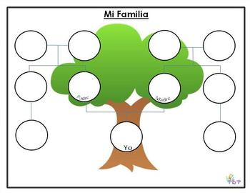
- Yo soy
- Mis padres son
- La madre de mi padre es
- El padre de mi madre es
- Mis abuelos son
- Mi tía es
- Los nietos de mis abuelos son
- Mi primo/a favorite/a es
Translate the possessive adjective chart.
English | Spanish
my
your (informal)
his
her
your (formal)
our
your all (Spain)
Their
Their (formal)

Complete the following sentences using the correct possessive adjective.
- ¿Dónde está ___ sombrero? (my)
- El carro es de ella – es ___ carro.
- Puedo usar ___ libro. (your – informal)
- Ella es _______ mama. (our)
- Pone ____ papeles en la mesa.

Conjugate the verb Estar.
Estar – to be
Yo |  | Nosotros/as
Tú |  | Vosotros/as
Él, Ella, Ud. |  | Ellos, Ellas, Uds.

Using the verb estar, tell how the following people feel based on the situation.
- Tengo mucho trabajo.
- La abuela de Penelope está enferma.
- Nosotros tenemos una fiesta hoy.
- Mi esposo y yo tenemos quince nietos.
- Vida y Dina llevan vestidos.

Discovery Video: Urban and Rural Puerto Rico
What two bodies of water surround Puerto Rico?
What does Puerto Rico mean? _________________________________________________________________________
When did Spain claim and colonize the island? ____________________________________________________________
What event (and when) caused Spain to relinquish Puerto Rico to the United States?
What does Puerto Rico’s commonwealth mean?
Can Puerto Rico vote for an United States President? _____ YES _____ NO
Do Puerto Ricans pay taxes? _____ YES _____ NO
What is the capital of Puerto Rico? _____________________________________________________________________
What 3 Countries influence Puerto Rico’s culture? _________________________________________________________
Describe Puerto Rico’s economy.
What is the name of the only tropical rainforest in the U.S. National Forest System?
__________________________________________________________________________________________________
Describe the diverse landscape of Puerto Rico.
How was Puerto Rico formed? _________________________________________________________________________
__________________________________________________________________________________________________

Discovery Video: Puerto Rico: The Coqui
Where did the Taino Indians live? _
_____________________________________________________________________
What do frogs symbolize? ____________________________________________________________________________
How many frog endemic species is Puerto Rico home to? ___________________________________________________
What does endemic mean? ___________________________________________________________________________
__________________________________________________________________________________________________
What two reasons do male coqui have to croak?
Where do coqui leave their eggs? ______________________________________________________________________
How long is the coqui tadpole stage? ___________________________________________________________________
What challenges do the coquis have?
What is chytrid? ____________________________________________________________________________________
What is chytridiomycosis? ____________________________________________________________________________
__________________________________________________________________________________________________

EXIT TICKECT: What new information did you learn from these videos?

Para Calentarnos: Translate the following Unidad 4, Lección Vocabulary from page 174.
Spanish | English
jugar al tenis
nadir
mirar fotos
ir de compras
patina (sobre ruedas)
ver (la) television
tocar el piano
bailar
comprar ropa
ir a un partido de fútbol
cantar
hacer las tareas

Classwork: Review p 175 Para conversar. Complete chart fill-in from p 175 Para decir más. Complete p 175 Actividades. Complete p 175 ¿Qué es? Review p 176 Estrategia. Translate p 176 Diálogo: Me gusta mucho. Complete p 176 ¿Qué recuerdas? Complete p 176 Algo personal.
English | Spanish
to go bowling
basketball
American football
hockey
clarinet
flute
guitar
text message

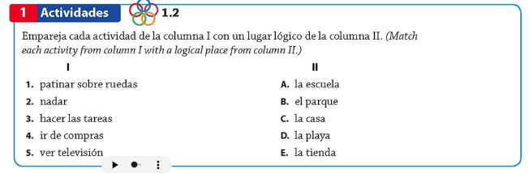
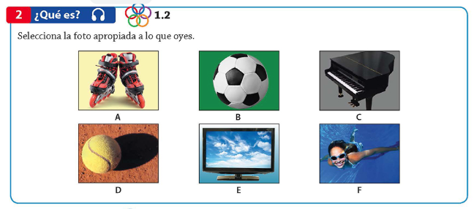

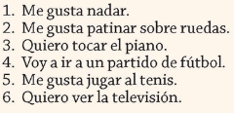
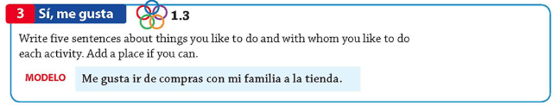

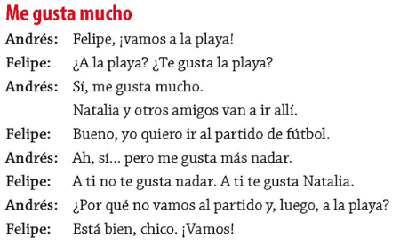
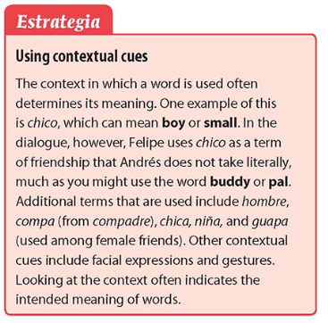
Title: ______________________________________________________
Andrés
Felipe
Andrés
Felipe
Andrés
Felipe
Andrés
Felipe
