Para Calentarnos: Study for SER Quiz
Discovery Video: Discoveries Dominican Republic
How long does it take to teach someone to kite surf? ______________________________________________________
Describe the lesson processes:
Why is kite surfing important to D R?
What is meant by experiencing “the texture of life?”
What country did D R take the #1 tour destination title in the Caribbean from? __________________________________
How much does it cost to purchase a condominium in D R? __________________________________________________
Describe the life in the Southern Dominican Republic.
Would you like to live in a place like that? Why or why not?
What is the name of the largest salt water lake in the Caribbean? ____________________________________________
How many international airports fly into D R? _____________________________________________________________
How many tourists visit D R? __________________________________________________________________________
What did Columbus name the Dominican Republic? _______________________________________________________
What year did Columbus land in D R? ___________________________________________________________________
Where did he go next? _______________________________________________________________________________
Describe how Spain secured the fortress.
Why was the fortress built? ___________________________________________________________________________
Magic Show: What was your favorite trick?

What can you find at the top of the mountain? Describe.
What is the most common mode of transportation? _______________________________________________________
What might you find transported?
How long does it take four people to milk 150 cows by hand? ________________________________________________
What is the capital of Dominican Republic? _______________________________________________________________
Describe the look of the colonial district.
What firsts’ where established?
What design is the cathedral? _________________________________________________________________________
How many times was the monastery (re)built? ___________________________________________________________
What is the design of the monastery? __________________________________________________________________
What three additional purposes did the monastery serve over the course of time?
From what three oppressors does D R celebrate their independence?
Why did Santo Domingo go through the expense of catering to cruise lines?
Describe a local market?
How is this different/similar to what you may find in the States?

What is the countries number one source of export revenue? _____________________________________________
What does it mean to be a developing country?
What examples are given of small businesses? Give at least two.
What percent of the country is living in poverty? __________________________________________________________
What percent of the world’s population live in poverty? ____________________________________________________
What’s going on at Bellevue High School?
How does this relate to Global citizenship?
What could you do to give back?
What sport is D R known for? __________________________________________________________________________

Exit Ticket: What is one new thing that you learned about the Dominican Republic?

Para Calentarnos: Complete p 195 Gramática, Section D.
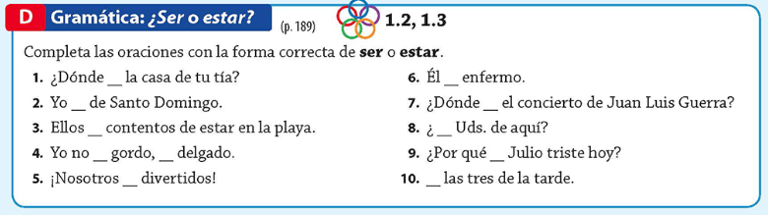
1. | 3. | 5. | 7. | 9.
2. | 4. | 6. | 8. | 10.

Classwork:Complete Ser vs. Estar packet.
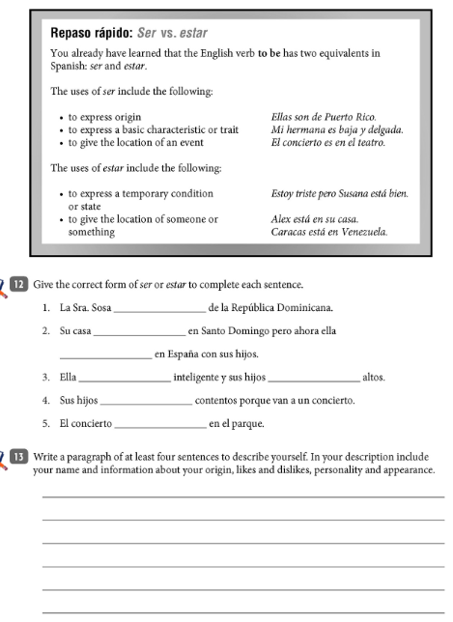
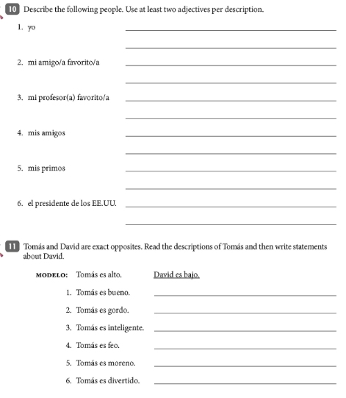
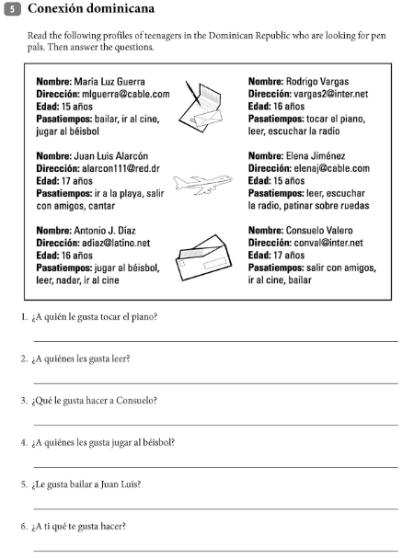
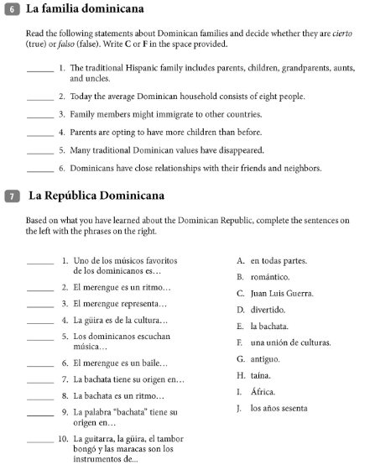

Para Calentarnos: Complete the section 1 activity:
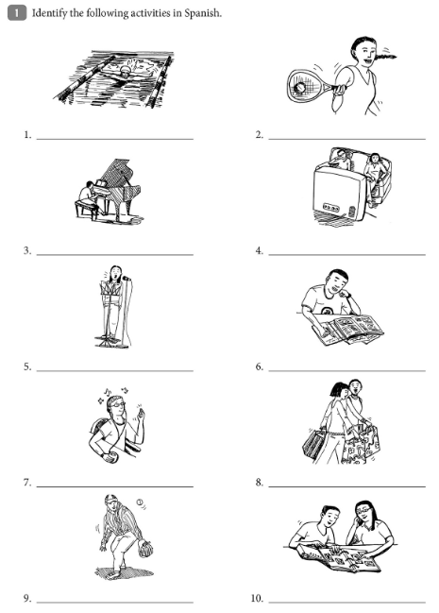

Classwork: Complete the Unidad 4, Lección B Packet.
