Para Calentarnos: Review the Maps. Complete ¿Eres de …?
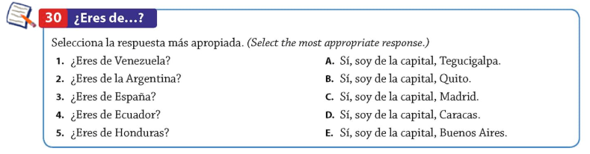
Classwork:
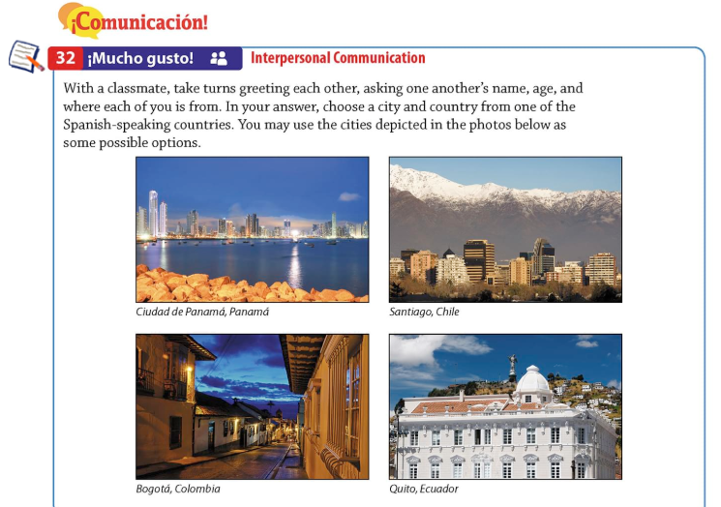
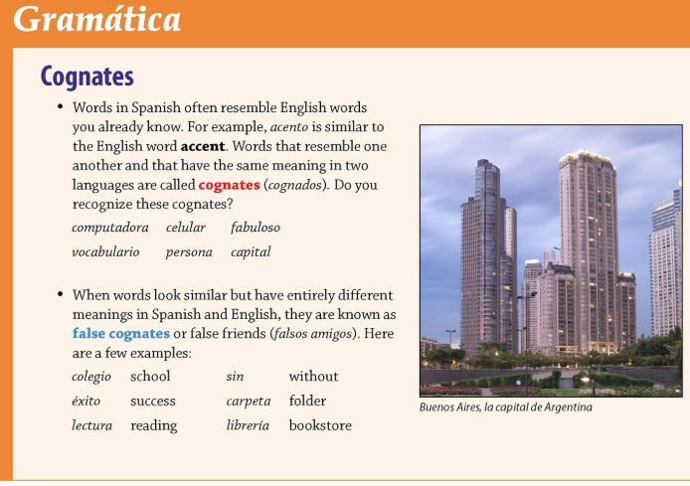
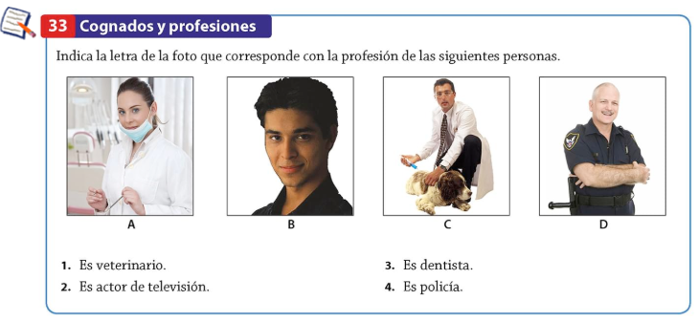
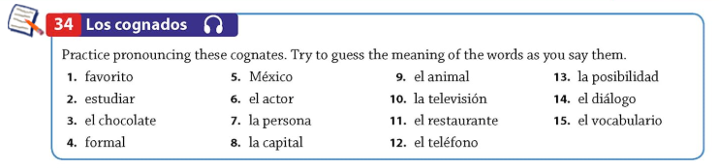
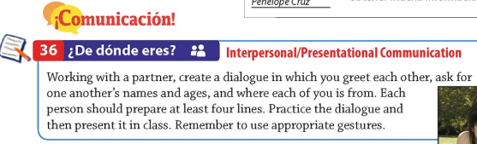

Para Calentarnos: Complete İComunicación!
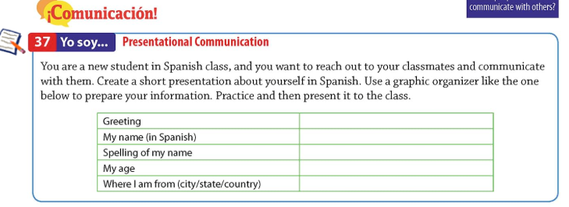
Classwork: Watch Video (https://drive.google.com/drive/folders/0B4trLn1Qs5-ISHQxVV90T2taOTA) and Complete the Following 2 Activities
