Para Calentarnos: Complete Section 1 and Place answers on your warm-up sheet.
Classwork: Complete the following. You may work with a partner quietly.
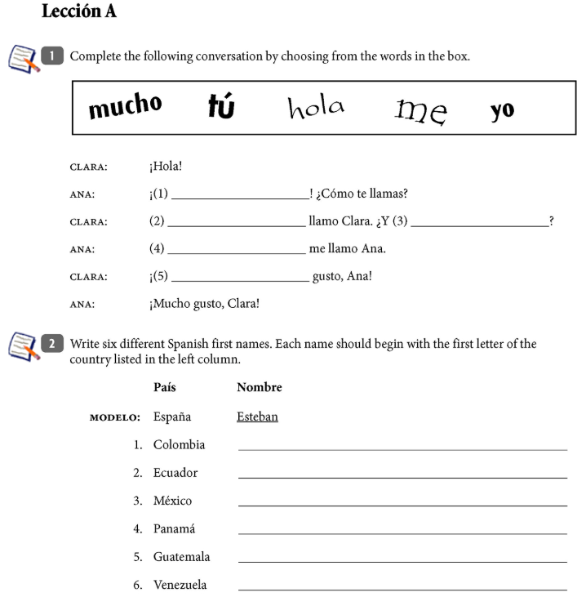
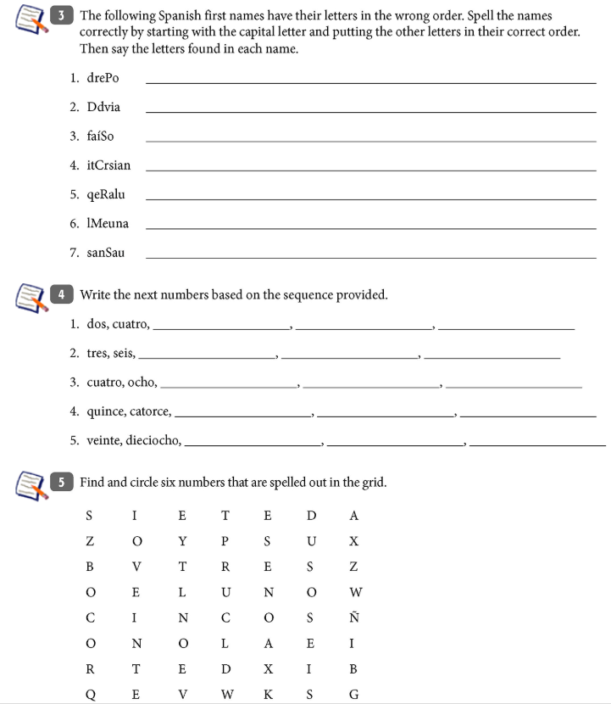

Para Calentarnos: Write 5 Spanish Speaking Countries
Classwork: Complete the following with your partner.
