Para Calentarnos: Complete İComunicacion! Hola, amigo 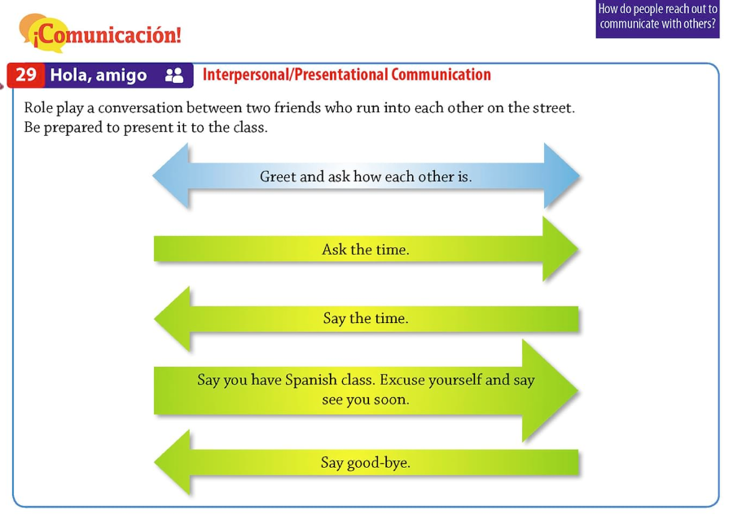
Classwork: Review Estrategia. Complete Los cognados. Complete El mundo hispanohablante. Complete Comprensión. Complete Analiza.

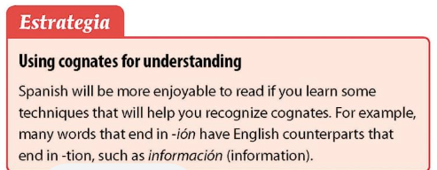
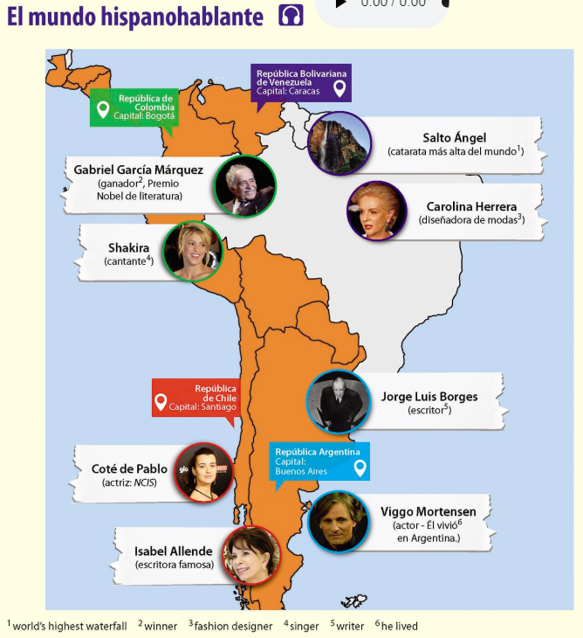
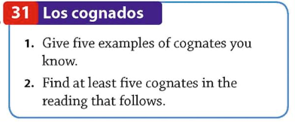
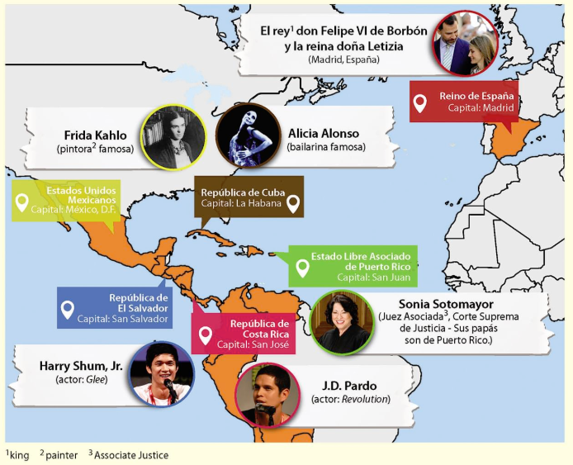
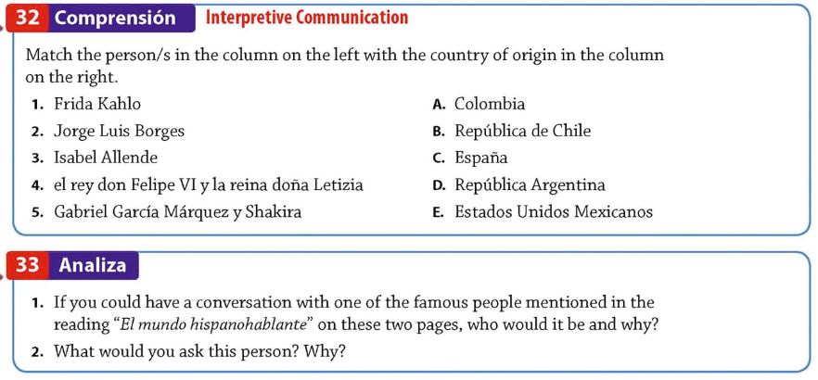

Review Estar Sentences, Make sure to have correct punctuation, capitalization, and spelling.

Estar – to be
(temporary, to express mood)
Yo | estoy | Nosotros | estamos
Tú | estás | Vosotros/as | estáis
Él, ella, usted | está | Ellos, Ellas, Ustedes | están

Estar – to be (temporary)
Ser – to be (permanent)
I | am | we | are
You (informal) | are | all of you | are
He, she, you (formal) | is, are | They | are

On a separate sheet of paper write the following sentences in Spanish:
- How are you? (formal)
- How are you? (informal)
- How is she?
- How is he?
- How are you all? (group of males)
- How are you all? (group of females)
- How are you all? (mixed group of both males and females)
- How are they? (males)
- How are they? (females)
- How are they? (mixed group of both males and females)
- How are they? (formal)
- I am well.
- She is very well.
- He is more or less well.
- We are well.
- You all are so-so.
- They (males) are very well.
- They (females) are very well.
- They (formal) are well.
- Why are bad? (Why do you feel bad?)
- I have a headache. / My head hurts.
- I have a stomachache. / My stomach hurts.
- My arm hurts.
- My hand hurts.
- My mouth hurts.
- My eyes hurts.
- My ear hurts.
- My leg hurts.
- My foot hurts.
- My tooth hurts.
- I am much better now.
- Thank you.
*Please complete the number chart below. Pay special attention to patterns.
uno | veintiuno | cuarenta y
dos | veintidós | cuarenta y dos
tres | veintitrés | cuarenta y
cuatro | veinticuatro | cuarenta y cuatro
cinco | veinticinco | cuarenta y
seis | veintiséis | cuarenta y seis
siete | veintisiete | cuarenta y
ocho | veintiocho | cuarenta y ocho
nueve | veintinueve | cuarenta y
diez | trenta | cincuenta | setenta | noventa
once | trenta y uno | cincuenta y
doce | trenta y | cincuenta
trece | trenta y tres | cincuenta y
catorce | trenta y | cincuenta
quince | trenta y cinco | cincuenta y
dieciséis | trenta y | cincuenta
diecisiete | trenta y siete | cincuenta y
dieciocho | trenta y | cincuenta
diecinueve | trenta y nueve | cincuenta y
veinte | cuarenta | sesenta | ochenta | cien

On the back of this paper, complete the math in Spanish.
(for example: uno x uno = uno)
2 x 0 = | 2 x 10 = | 2 x 2 = | 2 x 11 = | 2 x 4 = | 2 x 12 =
3 x 0 = | 3 x 10 = | 3 x 2 = | 3 x 11 = | 3 x 4 = | 3 x 12 =
4 x 0 = | 4 x 10 = | 4 x 2 = | 4 x 11 = | 4 x 4 = | 4 x 12 =
5 x 0 = | 5 x 10 | 5 x 2 = | 5 x 11 = | 5 x 4 = | 5 x 12 =

Complete Repaso as a “swap out” grade.
Repaso Unidad 1, Lección B
