Para Calentarnos: Complete p 52, İComunicación! Somos de muchos países.
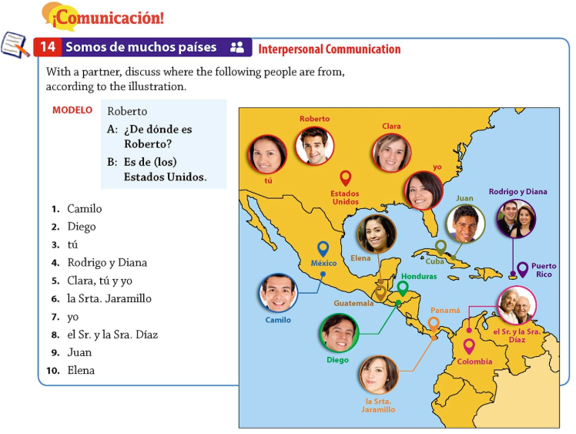

Classwork: View SER Video (found on Discovery Education). Take notes. Complete SER Sentences. Track the pattern and use the charts, just like we did with the Estar Sentences.
The five ways that we use SER:
- to tell time;
- to express nationality or country of origin;
- show possession;
- with nouns to identify something or someone;
- with an adjective to describe a trait or characteristic.

Ser – to be
(temporary, to express mood)
Yo | soy | Nosotros | somos
Tú | eres | Vosotros/as | sois
Él, ella, usted | es | Ellos, Ellas, Ustedes | son

Ser – to be (permanent)
I | am | we | are
You (informal) | are | all of you | are
He, she, you (formal) | is, are | They | are

On a separate sheet of paper write the following sentences in Spanish:
- Where are you from? (formal)
- Where are you from? (informal)
- Where is she from?
- Where is he from?
- Where are you all from? (group of males)
- Where are you all from? (group of females)
- Where are you all from? (mixed group of both males and females)
- Where are they from? (males)
- Where are they from? (females)
- Where are they from? (mixed group of both males and females)
- I am from ...
- You are from (informal) ...
- You are from (formal) ...
- She is from …
- He is from …
- You all are from (group of males) …
- You all are from (group of females) …
- You all are from (group of males and females) …
- They are from (group of males) …
- They are from (group of females) …
- They are from (group of males and females) …
- I am from the United States, not from Canada.
- She is from Venezuela, not from México.
- We are from Puerto Rico, not from Cuba.
Para Calentarnos: Match the subject pronoun (found in the box below) with the correct form of ser.
Nosotros/as yo usted ellos él tú
vosotros/as ellas ella ustedes

 | soy |  | somos
 | eres |  | sois
 | es |  | son
 | es |  | son
 | es |  | son

Para Calentarnos: Match the subject pronoun (found in the box below) with the correct form of ser.
Nosotros/as yo usted ellos él tú
vosotros/as ellas ella ustedes

 | soy |  | somos
 | eres |  | sois
 | es |  | son
 | es |  | son
 | es |  | son

Classwork: Review p 54, Cultura: El español en tu vida and Prácticas. Complete p 54, Comprensión and Analiza.
