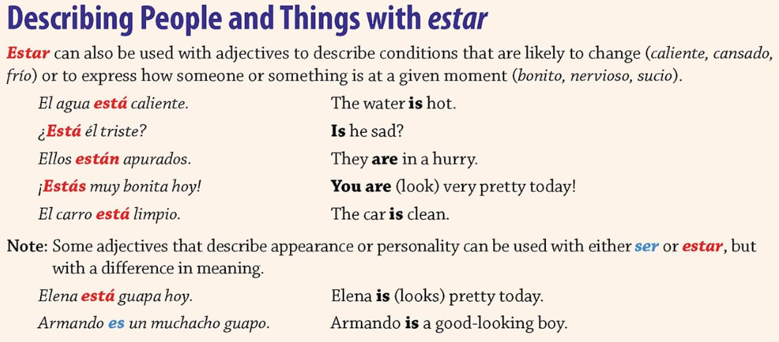
Nombre: ________________________________ Fecha: ________________________

Use your textbook to complete the following activities. Write your answers on the lines provided.
Activity 28, Page 165
- _____________________________________________________________________
- _____________________________________________________________________
- _____________________________________________________________________
- _____________________________________________________________________
- _____________________________________________________________________
- _____________________________________________________________________
Activity 29, Page 166
- ________________________________________________________________________________________________________________________________________________________________________________
- ________________________________________________________________________________________________________________________________________________________________________________
- ________________________________________________________________________________________________________________________________________________________________________________
- ________________________________________________________________________________________________________________________________________________________________________________
- ________________________________________________________________________________________________________________________________________________________________________________
- ________________________________________________________________________________________________________________________________________________________________________________
- ________________________________________________________________________________________________________________________________________________________________________________
- ________________________________________________________________________________________________________________________________________________________________________________

