In the mid-1700s, an Industrial Revolution began in ___________ that transformed the way work was done. Rather than making good by hand, new machines _________________ products which lowered _______, increased _________, and changed the way people lived. By 1900, industrialization spread through Europe and to the United States transforming the West into the dominant region of the world.
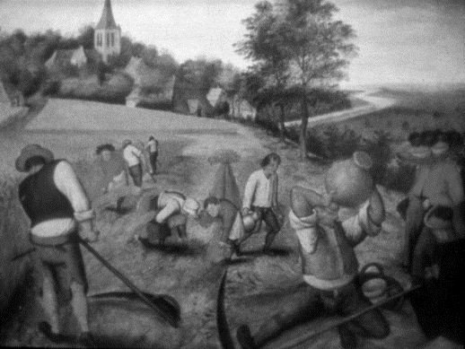
What was life like before the Industrial Revolution? __________________________________________________________________________________________________________________________________________________________________________________________________________________________________________________________________________________________________________
Before the Industrial Revolution, most people lived on ___________ and cities remained relatively ______________. Farmers relied on medieval and inefficient three field system. _______ farmers experimented with new farm techniques. As a result, the food that was produced kept the population of most countries from growing rapidly.
In the mid-1700s, new farm techniques led to an _____________ Revolution in Europe. Fences were used to protect large farms, called the Enclosure Movement. Scientific farming techniques like crop rotation maximized farmland and increased production. _________________________ like the iron plow and seed drill made farming more __________________.
As a result of this agricultural revolution, more _____________ was produced and Europe’s population increased. This large population of workers would soon find work in industrial factories.
The Industrial Revolution began in England for a variety of reasons. England had large deposits of natural resources, especially ___________ and _____________. They had banks, a government that encourage trade and invention, and ___________________ to invest in industry. England’s colonies provided cheap raw ____________________ and ____________________ to sell industrial goods.
From 1750 to 1850, England was the most __________________________ nation in the world.
What was the first industry to industrialize? __________________
The population boom created a demand for ________________ but traditional methods of textile making were __________________. As a result, the ________________ industry became the first to become industrialized.
New inventions sped up ________________, _____________________, and _____________________
European demand for cotton led to a boom in cotton production and _______________________ in the southern United States. Eli Whitney’s invention of the ___________________________ stimulated a demand for cotton textiles.
What is the relationship between Europe’s demand for cotton and slavery in the Southern US? __________________________________________________________________________________________________________________________________________________________________________________________________________________________________________
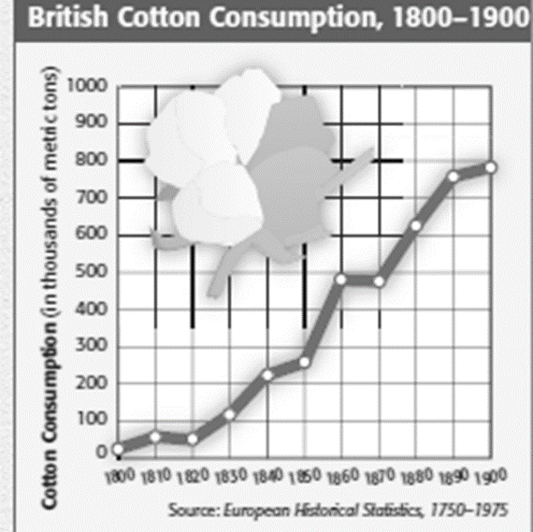
New textile machinery led to the ______________________. Power driven machines were able to mass produce goods very fast and cheap. Factory owners made huge _____________ selling mass produced clothes
The textiles industry and the rise of the factory system led to the growth of other industries. Factories needed power and were located near ________________.
Why? ______________________________________________________________________ __________________________________________________________________________________________________________________________________________________________________________________________________________________________________________
In 1765, _____________________ invented the first steam engine. Steam Engines produced more power and allowed factories to be built in _______________ near mass quantities of workers. Factories led to a demand for fast transportation. Roads and ____________ were built to allow for transportation of goods and people. Robert Fulton’s __________________ increased the speed of water travel. The greatest improvement to transportation was the steam-powered ________________. Railroads were fast, increased profits, and stimulated the iron and coal industries.
The Industrial Revolution led to an increase in ______________ to power factories and Railroads. ________________ was needed to produce new machines, engines, and railroad track. By 1800, England made more iron than all other nations in the world ____________________.
Henry Bessemer invented a cheap process for making ________________, which is stronger than iron. Steel allowed engineers to design more powerful machines, taller buildings, and longer bridges
Other inventions of the Industrial Revolution include ________________, new forms of communication such as the _____________ and ______________, business machines like ____________ and cash registers, and medical improvements like _____________________
The Industrial revolution soon spread throughout Europe and ________________. ________________ was quick to embrace new industrial technologies, as they had a large supply of coal and iron ore. Germans built a large network of railroads, iron, and textile factories. By the mid-1800s, Germany was one of the world’s industrial leaders, and built a powerful modern _______________. When do you think Germany’s modernization will be important?__________________________________________ _______________________________________________________________________________________________________________________________________________________________________________________________________________________________________________________________
Industrial ideas turned the United States into an important world power. _______________ cotton led to textile mills in the ___________________. After the Civil War in 1865, American industry boomed and the _________________________ became a world leader in railroads, oil, steel, electricity. Many US companies merged to form large corporations and ___________________.
From 1700 to 1900, revolutions in agriculture, industry, transportation, and communication changed Western Europe and the United States. Industrialization gave Europe tremendous ___________ and ______________ power. Industry also had numerous effects on working conditions and the standard of living for urban workers. In contrast, the economies of Asia and Africa were still based on ________________ and small workshops. Industrialization revolutionized every aspect of society, from daily life to ___________________. Despite the hardships early urban workers suffered, population, health, and wealth eventually rose dramatically in all industrialized countries. The development of a ___________________________ created great opportunities for _____________ and democratic participation. Greater democratic participation, in turn, fueled a powerful movement for social __________________.
American Industrialism
Robber Barons and Captains of Industry
JD Rockefeller, JP _______________, Andrew Carnegie, Cornelius Vanderbilt and Henry ___________________ were leaders in the _________________ and financial world and influenced political and social activity in the United States.
Henry Ford established the Ford company where he perfected the __________________________ process and produced the ________________________ from 1908-1927, a car that was more _________________ to many Americans than previous vehicles. The Model T, also known as the Tin Lizzie, was simple to drive and ______________ to repair. Nearly _________ of all cars in America in 1918 were Model T’s. The moving assembly line changed car production times from ___________ hours to 2 hours and 30 minutes. This lowered the cost of the Model from $850 in 1908 to $_____________ by 1926. Ford introduced the $5 wage for an 8-hour work day, more than double what workers were previously making on average. He was a __________ and established the Ford Foundation in 1936 to provide grants for research, education, and development. Despite his philanthropic leanings, he was a committed _________________ and published writings to further his viewpoint.
__________________ became one of the wealthiest and most powerful businessmen in the world through his founding of _________________ banks and industrial consolidation in the 1800s. He co-founded the banking form that became JP Morgan and Co. in 1871, and in the 1880s, he established himself as a power player in the country’s railroad industry. He led efforts to bail out the _____________________ in __________ and ___________. The Panic of 1893 was an economic disaster due to the serious depletion of US gold reserves. Morgan convinced President Grover Cleveland to allow Morgan and other investors to supply ___________ in exchange for a favorable rate on 30 year _________, which stabilized the economy. Morgan bought Carnegie Steel in 1901 for nearly $500 million, creating _________________, the first _______________-dollar corporation. In 1902, the Justice Department charged Northern Securities, one of his railroad companies, with violating the ______________________ of 1890. JP Morgan and Co was the official bank of the country of __________________.

