Student
Handbook
Mission Statement and Beliefs
School Name: ______________________________________________________________________
Address: ___________________________________________________________________________
Phone Number: ____________________________________________________________________
Hours of School Day: ________________________________________________________________
Grade Levels We Serve: _____________________________________________________________

Our Mission Statement is…
____________________________________________________________________________________________________________________________________________________________________________________________________________________________________________________________________________________________________________________________________________________________________________________________________________________________________________________________________________________________________________________________________________________________
The History of Our School:
____________________________________________________________________________________________________________________________________________________________________________________________________________________________________________________________________________________________________________________________________________________________________________________________________________________________________________________________________________________________________________________________________________________________
About the Designer of the School:
____________________________________________________________________________________________________________________________________________________________________________________________________________________________________________________________________________________________________________________________________________________________________________________________________________________________________________________________________________________________________________________________________________________________

Academics/Curriculum
At our school, we strongly believe in teaching our students the finest of subjects. It is very important that our students are learning material that will help him or her be successful in school and in life. Please read the chart below to learn more about the academic classes being taught and our wonderful teachers who devote endless hours to these classes.
Academic Core Class | Grade Level

Electives
In addition to academic core classes, we strongly believe that students deserve the opportunity to choose elective classes from the list that we offer. Please read below to be able to make your selection. You will see that our elective classes are unique, creative, and entertaining. They are also tied to the overall mission of our school.
Elective | Description | Grade Level

Student Activities and Clubs
It is important to us that our students enjoy being on our campus at all times. To help this cause, we offer a variety of student activities. Examples include: dances, fundraisers, Red Ribbon Week, etc. Below is a list of the student activities being offered throughout the school year. Enjoy!
Activities

In addition, your student has the opportunity to join student clubs that help sponsor different events on campus. The following clubs are available:
Club | Description

Student Requirements
At our school we proudly serve students in grade __________ to grade __________. While we are happy to accept many students, there are three expectations or requirements that each student needs to meet to be a part of our school family. They are listed below.
- ________________________________________________________________________________________________________________________________________________________________________

- ________________________________________________________________________________________________________________________________________________________________________

- ________________________________________________________________________________________________________________________________________________________________________
Failure to meet these requirements will result in:
___________________________________________________________________________________________________________________________________________________________________________________
Dress/Hair Code: Please read our guidelines on dress code for girls, boys, and teachers.
Student | Teachers

School Calendar
Below is a calendar for the upcoming school year, 2019-2020. Please use the color coded legend below to read the calendar. The color on the legend will match the days in the month. Contact the office for any questions.
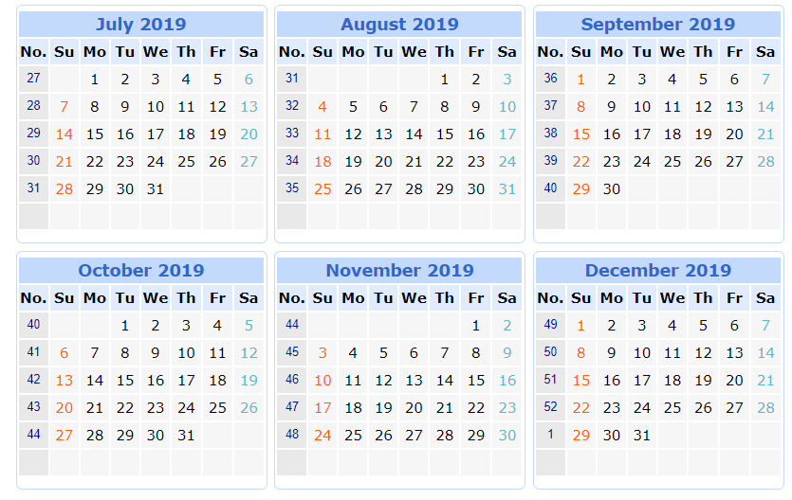

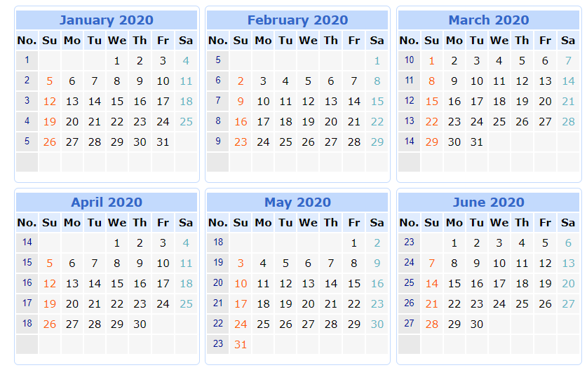

Legend:
- First Day of School
- Last Day of School
- Thanksgiving Break
- Winter Break
- Spring Break

Regarding School Safety
The following precautions will be taken to ensure the safety of all of our students:
- ________________________________________________________________________________________________________________________________________________________________________

- ________________________________________________________________________________________________________________________________________________________________________

- ________________________________________________________________________________________________________________________________________________________________________

