Study Guide: Energy Transfer
Due: ________________

(food chains, food webs, and energy pyramids)
.
If you have internet or internet access, you may want to visit:

http://www.sheppardsoftware.com/content/animals/kidscorner/foodchain/foodchain2.htm

- Using the following food chain, answer the questions below.

Grass Rabbit Fox

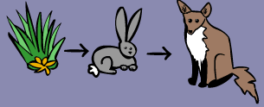

- What type of organism is the grass? _____________________________

- Which animal is an herbivore or primary consumer? ___________________________

- What would happen to the population of rabbits, if the population of foxes decreased?
_______________________________________________________________________________________________________________________________________________________________________________________________________________________________________

- Construct a food chain. Label the (1) producer, (2) primary consumer, (3) secondary consumer, and (4) tertiary consumer. Remember to use arrows..

A hawk eats a snake, the snake eats a squirrel, the squirrel ate a nut.

- Using the food chain from question 2,
construct an energy pyramid.

  - Which animal has the most amount of available energy? ____________________________________

  - Which animal has the least amount of available energy? ____________________________________
- Use the food web below to answer the questions.

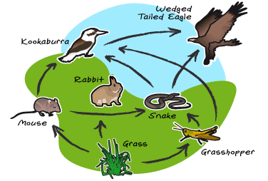

  - Which is a producer? ____________________________________________________________________

  - Which are the primary consumers? (Hint: there are three)

_________________________________________________________________________________________

  - Which are the two secondary consumers?

_________________________________________________________________________________________

  - Which is the tertiary consumer? ___________________________________________________

  - Which is the top predator? ________________________________________________________________

- Construct one food chain that you see in the food web.

- Using your food chain above, construct an energy pyramid.
Trophic Levels
The feeding positions in a food chain or web are called trophic levels. The different trophic levels are defined in the Table below. Examples are also given in the table. All food chains and webs have at least two or three trophic levels. Generally, there are a maximum of four trophic levels. Many consumers feed at more than one trophic level.

Table: Trophic levels

Trophic Level | Where It Gets Food | Example
1st Trophic Level: Producer | Makes its own food (Autotroph) | Plants make food
2nd Trophic Level: Primary Consumer | Consumes producers (Heterotroph) | Mice eat plant seeds
3rd Trophic Level: Secondary Consumer | Consumes primary consumers (Heterotroph) | Snakes eat mice
4th Trophic Level: Tertiary Consumer | Consumes secondary consumers (Heterotroph) | Hawks eat snakes

Trophic Levels and Energy
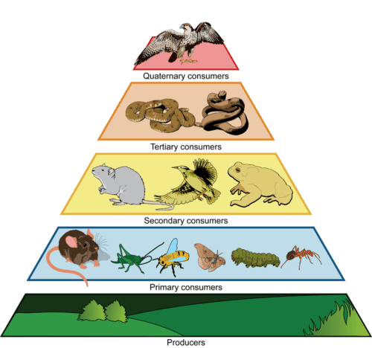
Energy is passed up a food chain or web from lower to higher trophic levels. However, generally only about 10 percent of the energy at one level is available to the next level. This is represented by the energy pyramid in the Figure 1 below. What happens to the other 90 percent of energy? It is used for metabolic processes or given off to the environment as heat. This loss of energy explains why there are rarely more than four trophic levels in a food chain or web. Sometimes there may be a fifth trophic level, but usually there’s not enough energy left to support any additional levels.

Review
- What is a trophic level?
- What do energy pyramids represent?
- Explain how energy limits the number of trophic levels in a food chain or web.

What is an autotroph?____________________
______________________________________
What is a heterotroph? ___________________
______________________________________

Figure 1

*adapted from: http://www.ck12.org/biology/Trophic-Levels/lesson/Trophic-Levels-BIO/

Energy Flow Through the Ecosystem Study Guide
Word | Description/Definition | Example/Picture
Biotic Factor
Abiotic Factor
Ecology
Ecosystem
Organism

Producer

Consumer

Decomposer

Food Chain

Trophic Level(s)

Food Web

Energy Pyramid

