The Four States of Matter
Matter exists in four states. Each is characterized by its physical properties. The four states of matter are solids, liquids, gases, and plasmas.
Solids are materials that have a definite shape and a definite volume. One example would be an ice cube. An ice cube is a six-sided object. Its volume can be determined by multiplying its height, depth, and width.
The particles in an ice cube are molecules of water (H₂O). They are densely packed and vibrate in fixed positions. Solids are almost incompressible. This means they resist being packed together more tightly.
Liquids are materials that have an indefinite shape and a definite volume. Liquids take the shape of the container they occupy. However, they do not expand to fill the container they occupy.
For example, liquid water in a graduated cylinder will take the shape of the cylinder. The water has a definite volume. This volume can be determined by reading the cylinder’s scale. The water will fill only a certain amount of space in the cylinder. In other words, 50 mL of water in a 100 mL cylinder will not expand to fill the cylinder. The volume will remain 50 mL.
The particles in liquid water are relatively loosely arranged. They are somewhat free to move past one another. Liquids are almost incompressible. Like solids, they resist being packed together more tightly.
Gases are materials that have an indefinite shape. They also have an indefinite volume. Water vapor, which is a gas, will take the shape and volume of the container in which it is enclosed. This means that the volume of a sample of water vapor will vary with the volume of its container.
For example, water vapor contained in a 1 L bottle will have a volume of 1 L. The same mass of water vapor contained in a 2 L bottle will have a volume of 2 L.
The particles of a gas are widely separated. They are very free to move from one place to another. Gases are compressible.
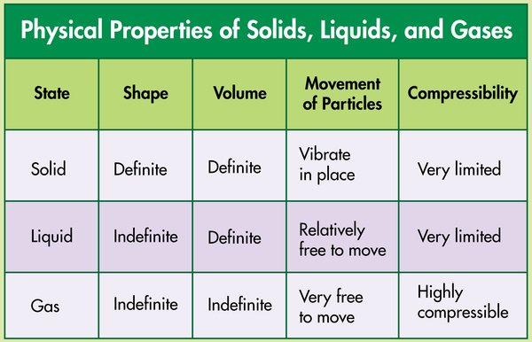
Each of these states of matter can be transformed into the other states of matter. A change of state occurs when enough energy is added or subtracted from the matter. This is commonly accomplished by adding or subtracting heat from the matter. For example, adding heat transforms a solid ice cube to a liquid, and adding additional heat transforms a liquid to a gas. Cooling a gas such as water vapor transforms the gas to a liquid, and cooling it further transforms the liquid to a solid.
Physical Properties of Solids, Liquids, and Gases
Plasma is the fourth state of matter. A plasma is similar to a gas in some ways, but particles in the plasma state have much greater kinetic energy. When atoms or molecules absorb extremely high amounts of energy, they break apart into ions and free electrons. The electric charges of these ions and electrons affect the properties of plasma. Usually the energy absorbed when gas changes to plasma is in the form of heat and involves temperatures greater than 5000 °C.
Conditions on Earth’s surface do not naturally sustain matter in the plasma state. While plasma does exist in Earth’s atmosphere for short periods of time, it is unstable. Plasma on Earth quickly releases energy and returns to the gas state. Examples include static electricity (which we see as lightning) and the auroras.
How are pure substances distinguished from mixtures?
Pure Substances
Different kinds of matter fall into three classifications. These are elements, compounds, and mixtures. An element is a form of matter that consists of only one kind of atom. A compound consists of the atoms of two or more elements.
Elements and compounds are pure substances. A pure substance is a type of matter whose samples, wherever found, have the same chemical properties. Mixtures are combinations of pure substances that are not chemically bonded.
Iron is an element and, therefore, a pure substance. An iron sample found in the United States will have the same physical and chemical properties as an iron sample found anywhere else on Earth or even on Mars.
For example, all samples of iron will be shiny, silvery-gray, and solid at room temperature. The samples will have a density of 7.87 g/cm³, melt at 1538 °C, and boil at 2861 °C. They will react chemically with oxygen to form iron oxide, or rust.
There are over 100 known elements. Each is a pure substance that possesses its own unique set of physical and chemical properties. An element’s properties are the same no matter where it is found.
Pure Substance vs. Mixture

Which of the following correctly compares a pure substance to a mixture?
A.A pure substance can only be separated by physical means, whereas some mixtures can be separated by chemical means.
B. A pure substance can only be separated by chemical means, whereas some mixtures can be separated by physical means.

C.
<div tinymce="true" use-dimensions="false">Both pure substances and mixtures can be separated by physical means.<br></div>
Both pure substances and mixtures can be separated by physical means.

D.
<div tinymce="true" use-dimensions="false">Both pure substances and mixtures can be separated by chemical means.<br></div>
Both pure substances and mixtures can be separated by chemical means.

