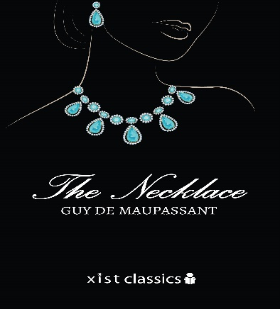
The Necklace
CAFÉ MENU
Appetizer
(Pick one)
Setting, Mood, and Theme: Create a Story Cover: Tell students that they are going to design a story cover for this short story. The story cover should entice readers to read the story, and it should also give potential readers a glimpse into the setting, mood, and theme of the story. Students may look at the photographs in the story to give them ideas as to how setting and mood can be revealed through art. Have students either illustrate or use any graphic design software to create the story title and cover. Students should consider the use of color, physical images, and other artistic elements that help them accurately convey the setting, mood, and theme of the story.
Or
Compare and Contrast: “Cinderella” and “The Necklace” Explain that many readers of “The Necklace” have commented on similarities between it and “Cinderella.” In a class discussion, have students compare and contrast aspects of the stories, including the two main characters and the key events.
Main Corse:
(Pick one)
Mini Body Biography: Using your steal chart you will complete a mini body biography of Madame Loisel. On the Left Side, you will have her before she changed and on the right, you will have her after she has changed. Remember to use the rough draft template. You will be creating a written and visual portrait of a character from the story that you are reading. Use this sheet provided to take notes before you create your project. You will be responsible for analyzing the main character using the guidelines provided.

Or

Writing in Character: Hidden Diary Ask students to imagine that Madame or Monsieur Loisel is keeping a hidden diary. Have students write four entries from the point of view of one of the two characters: one at the beginning of the story, one the night of the ball, one five years after the ball, and one after Madame Loisel’s encounter with Madame Forestier.

Dessert
(Pick one)
Vocabulary: Select 10 words from the story that you are unfamiliar with. Infer the words meanings, and Create an original sentence for each of the words.
Draw: Nineteenth-Century Fashion Collage Have students make a collage of fashion styles for men and women of different classes in nineteenth century France. Encourage students draw illustrations as well as text and objects that represent the era. Suggest that students look at photo’s in the book and print online illustrations and photos on their own time.
Poem: Write a poem about your character or from your character’s perspective. Your poem should tell us about your character’s speech, thoughts, effects on others, actions, and looks.

