Theme
Advertisement
Image
Headline
Human Interest Story

Name:_____________________________________

Directions
Thematic Statement
Determine the theme of “Through the Tunnel.” Write your theme in the theme box on the front. Refer to your notes if you have issues determining the theme.

Human Interest Story
The next activity requires you to think about tone and how authors use diction to convey the tone.
First, write a headline about the boy’s experience using one of the tones below:

Inspirational or Uplifting tone
Sarcastic or Mocking tone
Ominous tone
Admiring tone

Now, write a human-interest story about the boy and his feat. Be sure that the tone of your article is consistent with the headline’s tone. Be sure to reveal information about the boy’s character and describe the different conflicts that he faced. (You may also choose to complete this task in interview format.
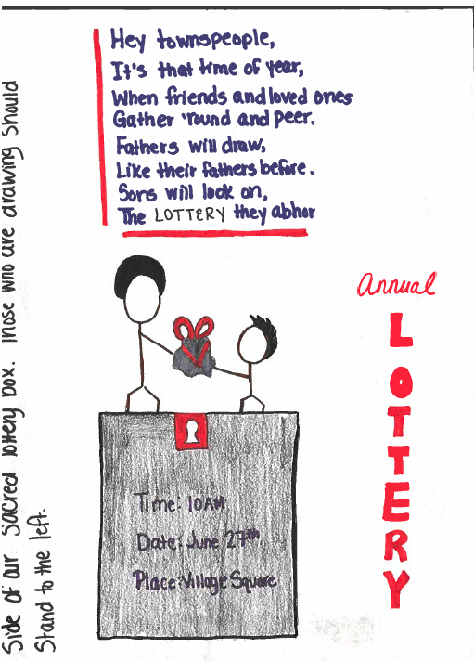
For the advertisement and image:
Create an advertisement of the beach resort that has one of the following tones (circle the tone that you plan to convey):
1. Calm or Tranquil
2. Desperate
3. Childish
4. Informative
Remember that in an advertisement, images, colors, fonts, and wording will all play a major role in the presentation of the tone. Check out the example(to the left) and the description (below) that were created for Shirley Jackson’s “The Lottery.”
This advertisement depicts a nostalgic tone for several reasons. First, the picture is of a father handing over a “special” rock to his son. It shows that this is a traditional and favored practice. Second, the poem speaks to the idea that this is a process that fathers and sons have always and will always take part in. The illustrator uses colors (red, gray, black and purple) to convey a serious tone. She also uses the black box, which was a symbol in the story.

