Trial Evidence Chart
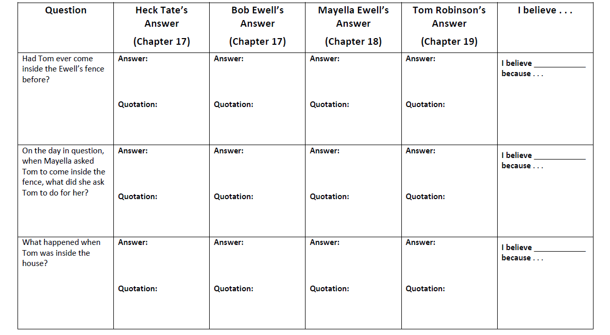
Directions: As you read chapters 17-19, fill in the chart with each witness’s answers to the questions on the left. In each box, provide both a complete sentence that answers the question and a quotation from the novel to support your answer. After you have filled in the chart, use the information to decide who you believe is telling the truth for each question. You will need to give a reason for your decision.
