Name: _______________________________________________________ Date: ________
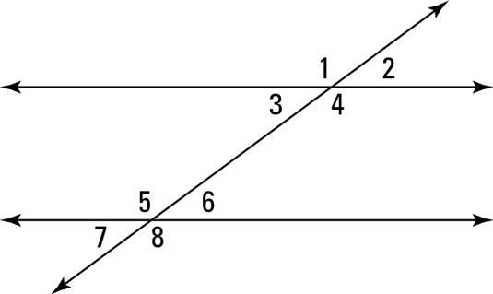

Vertical Angles:

Linear Pair:

Corresponding:

Alternate Interior:

Alternate Exterior:

Consecutive Interior:

