Name: ________________________________________________________ Date: ______________

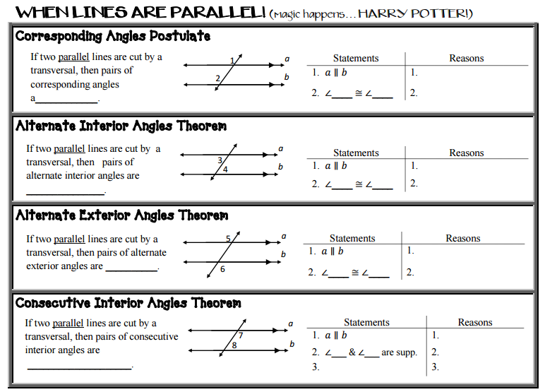

For the following, solve for X by creating a two-column proof. Given:

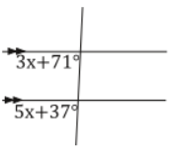

2

*m*

*n*

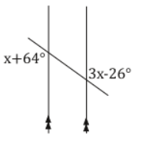

136°

*m*

*n*

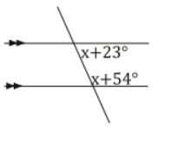

*m*

*n*

117°

