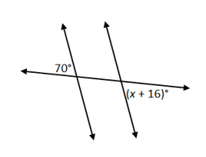
For the following three problems, solve for X using a two-column proof to justify your solution.

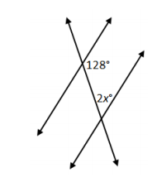

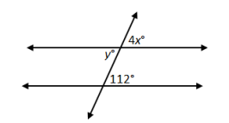

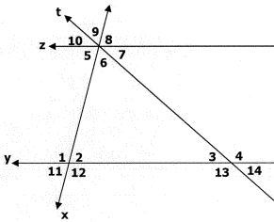
Given $Z∥Y$, $m∠9=63°$ and $m∠4=134°$. Find all missing angle measures.

Name: _____________________________________ Date: ______________

Transversals Proof Worksheet
2
1
4
3
5
6
7
8
S
R

- Given Line S II R. Prove that$∠6≅∠7$. What Theorem are we proving? _______________________.

- Given Line S II R. Prove that$∠3≅∠6$. What Theorem are we proving? _______________________.

- Given Line S II R. Prove that$m∠3+m∠5=180$. What Theorem are we proving? ______________.

- Can you prove the following? Why or why not? Given Line S II R. Prove that$∠4≅∠8$

