PERIODIC TRENDS QUIZ:
Label the trend for atomic radii (size).
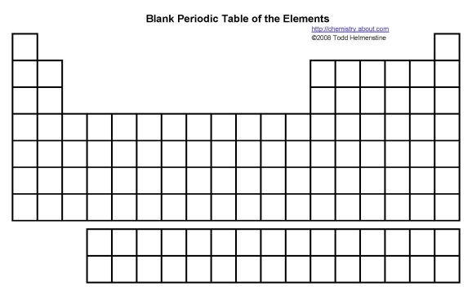

What causes the trends seen for atomic radii down a group and across a period?

Label the trend for Ionization Energy.
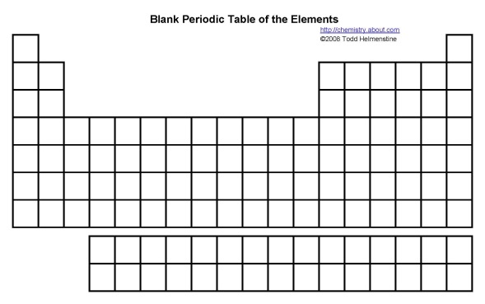

Explain the trends for ionization energy down a group and across a period.

Label the trend for Electronegativity
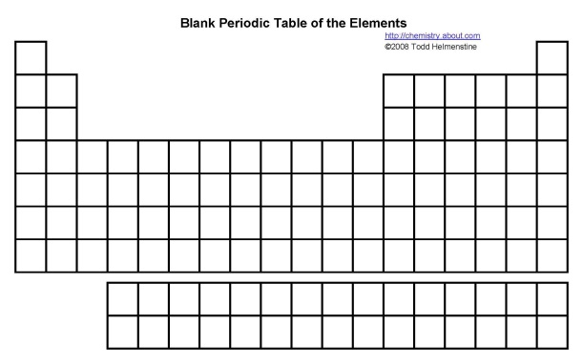

Why is the definition of electronegativity? What makes it different from Electron Affinity?

