Triangle Congruency Theorem Notes

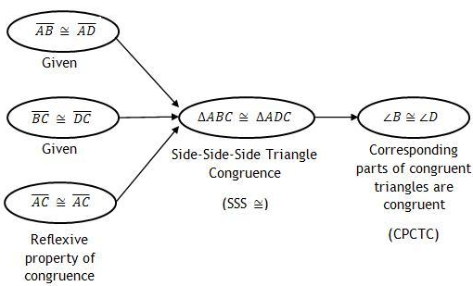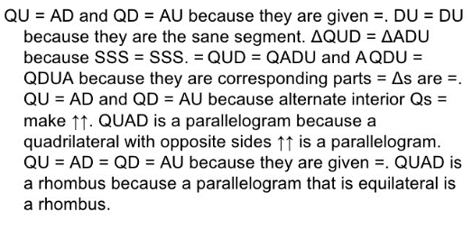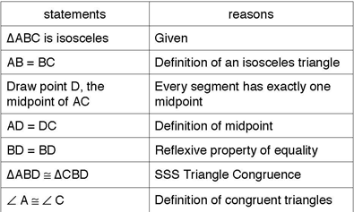Three Types of Proofs:

________________________ ________________________ ________________________

5 Triangle Congruency Theorems:

|  |  |  |
| --- | --- | --- |
| Triangle Congruency Theorem | Description | Example |
|  |  |  |
|  |  |  |
|  |  |  |
|  |  |  |
|  |  |  |

Examples:

Screen ClippingScreen Clipping

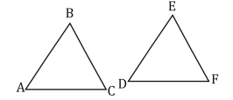

Screen ClippingScreen Clipping



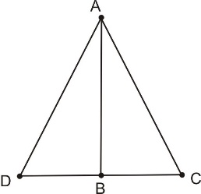Screen Clipping

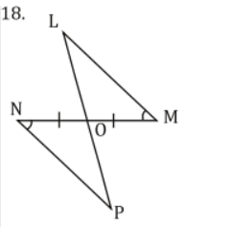

Given:

Given: ,