Name: ______________________________________________________ Date: ______________
Intro to Triangle Congruency Proofs Worksheet
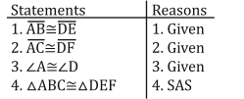
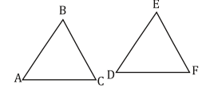
For the following. Mark off the given information and complete the proof.
1.

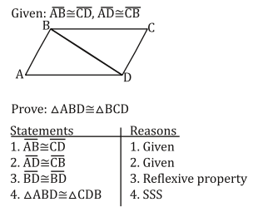
2.

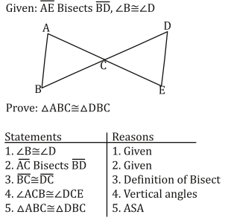
3.

