Mark the given triangle to match the triangle statement then state whether it is a congruency statement that we can use.

Triangle Statement | Mark the Triangle | Is it a congruency we can use?
AAA
AAS
ASA
HL
SAS
SSA
SSS

Triangle Statement | Mark the Triangle | Is it a congruency we can use?
AAA | 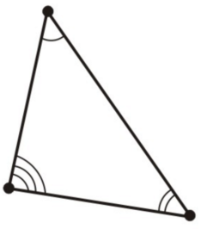 | No
AAS | 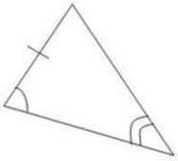 | Yes
ASA | 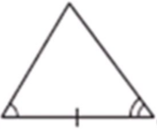 | Yes
HL | 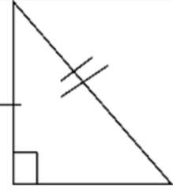 | Yes
SAS | 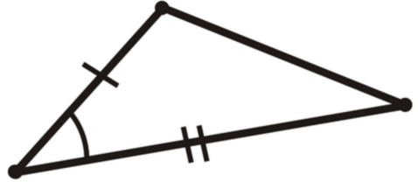 | Yes
SSA | 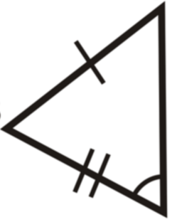 | No
SSS | 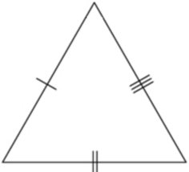 | Yes

