Name: _________________________________________ Date: _____________________

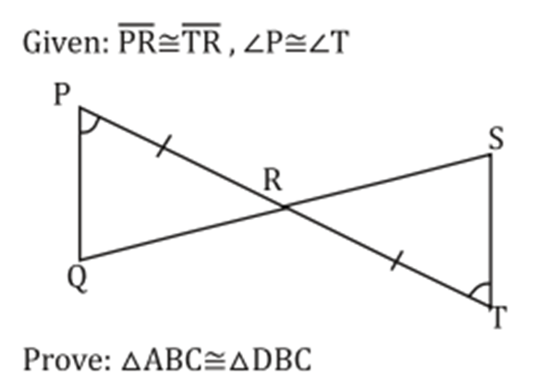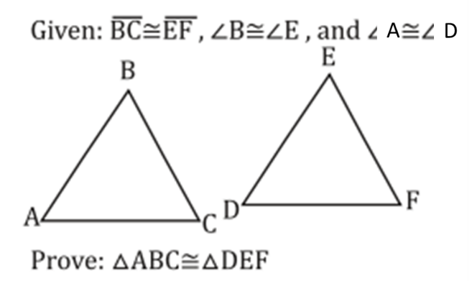Triangle Proofs Notes

