Name: _______________________________________________ Date: ______________

Triangle Sum & Exterior Angle Theorem Worksheet

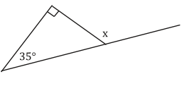For the following, find the value of x.

1. 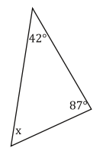 2.

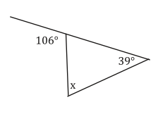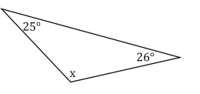

3. 4.

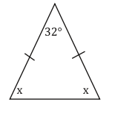5. 6.

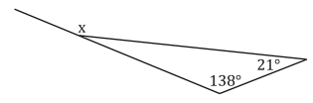

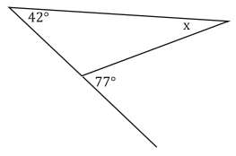

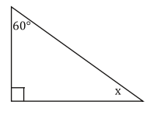7. 8.

For the following, set up an equation and solve for x, then find all angle measures.

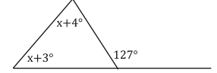9.

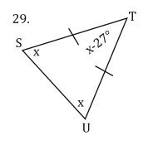

10.

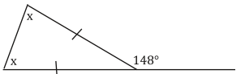11.

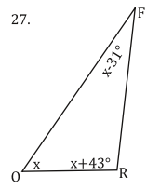

12.