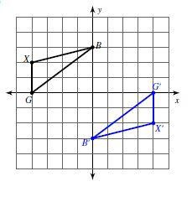
- Write a rule for the following transformations and explain how you know the two shapes are congruent.
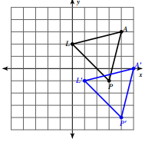

- Pick one problem from #1 and write out the three corresponding sides and the three corresponding angles.

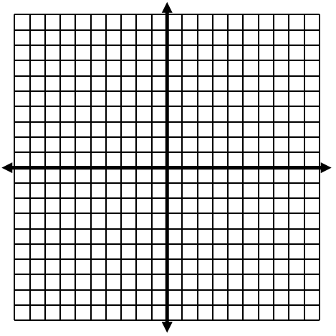
- Given point J is (2, -3), point A is (2, 5), and point B is (4, 4), reflect $∆JAB$ over the line y=x.

- What sequence of transformations will carry the pre-image to the final image in the drawing?

- First Transformation: __________________________ Rule: _________________

- Second Transformation: _______________________ Rule: _________________
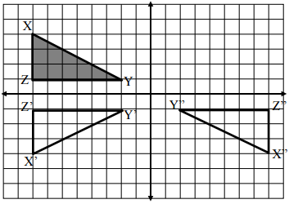
- Label the quadrants on the
graph.

- Which quadrant is the only
one that does not contain
a triangle?

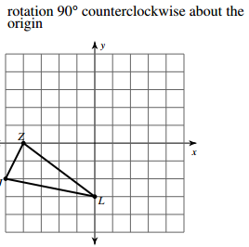
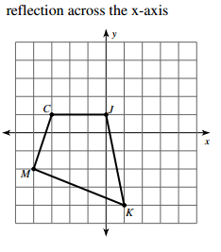
y=0

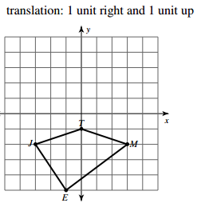
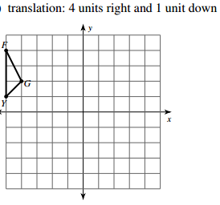
$$(x,y)→(x+1,y+1)$$
$$(x,y)→(x+4,y-3)$$

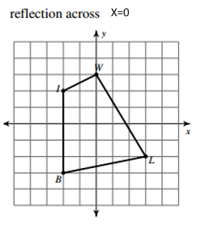
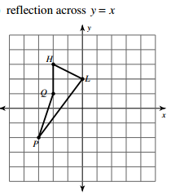
rotation 180° about the origin

For numbers 7 & 8, use what you know about isometric transformations to find all missing measurements.
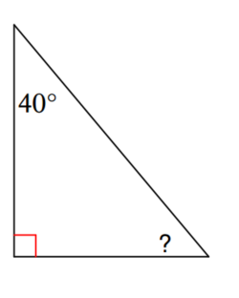
Q
P
12cm
P’
15cm
R
R’
Q’

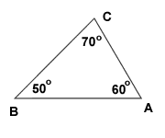
A’
B’
C’
11
7
13
52°

47°

Name: _____________________________________________________ Date: ________
Geometry Unit 2 Assessment Review
Determine where each bullet should be placed in the Venn diagram.

- $(x,y)→(x-6,y+7)$
- 90° Clockwise
- Across the line x=3
- Area and Perimeter stay the same.
- Preserves side lengths
- Angles measures stay the same
- Isometric
- Coordinates of the points stays the same.
- Orientation of the points stays the same.
- Distance between image & pre-image is preserved.

Translations
Rotations
Reflections

