Name: __________________________________________________ Date: _______

- Find the distance between the following coordinates: $(3, -1)$ and $(-2, 5)$.

- Given J (-4, 6) and K (2, -2). Find the points that partition line segment in a ratio of 3:1.

- How would number 2 have been different if it was a directed line segment?

- Given line AC is three times as long as BC solve for X. AC=60 BC=5x-5
A
B
C

- For the following diagrams. Set up an equation to solve for x. Write a justification for your equation.
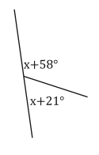
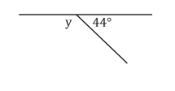
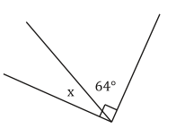
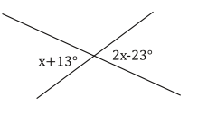
A.
B.
C.
D.

35°
57°
4x+62°
6x+30°
4x+30°
6x+20°

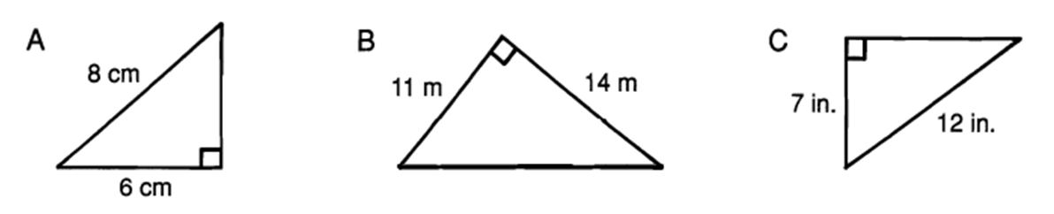
- For each right triangle, find the length of the side that is not given.

10
12
16 m
13 in.

- Write a rule for the following transformations and explain how you know the two shapes are congruent.

A. Transformation: ______________ B. Transformation: ______________
Rule: _______________________ Rule: _______________________
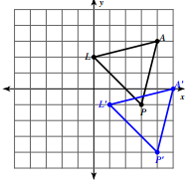
Congruent: __________________ Congruent: __________________

- Perform the following transformations:
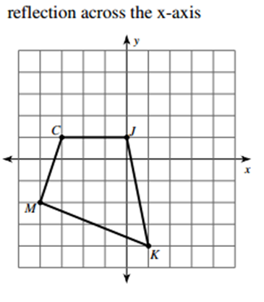
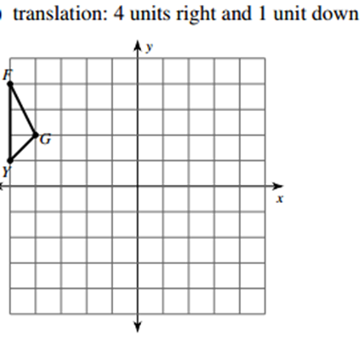
A.
B.

7. Draw a sketch of the coordinate plane and label the four quadrants.

