Unit 1 Exam- The Mystery
Review

Lesson 1.1 Investigating the Scene
Understandings
- Principles of biomedical science can be used to investigate the circumstances surrounding a mysterious death.
- Experiments are designed to find answers to testable questions.
Knowledge and Skills
- Recognize that processing a crime scene involves purposeful documentation of the conditions at the scene and the collection of any physical evidence.
- Describe how evidence at a crime scene, such as blood, hair, fingerprints, and shoeprints can help forensic investigators determine what might have occurred and help identify or exonerate potential suspects.
- Recognize that bloodstain patterns left at a crime scene can help investigators establish the events that took place during the crime.
- Recognize that all external variables in an experiment need to be controlled.
- Analyze key information gathered at a simulated crime scene.
- Design a controlled experiment.
- Graph and analyze experimental data to determine the height associated with bloodstain patterns.
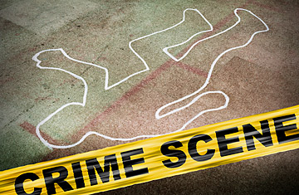

Lesson 1.2 DNA Analysis

Understandings
- Human DNA is a unique code of over three billion base pairs that provides a genetic blueprint of an individual.
- DNA is packaged as chromosomes, which each contain numerous genes, or segments of DNA sequence that code for traits.
- DNA from all living organisms has the same basic structure – the differences are in the sequences of the nucleotides.
- Restriction enzymes recognize and cut specific sequences in DNA.
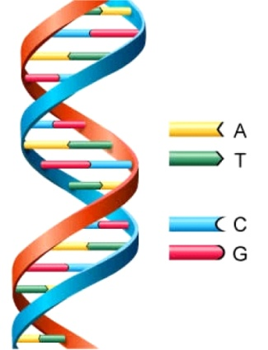
- Gel electrophoresis separates DNA fragments based on size and is used in Restriction Fragment Length Polymorphism (RFLP) analysis.
Knowledge and Skills
- Describe the relationship between DNA, genes, and chromosomes.
- Describe the structure of DNA.
- Describe the structure of a nucleotide.
- Explain how restriction enzymes cut DNA.
- Describe how gel electrophoresis separates DNA fragments.
- Recognize that gel electrophoresis can be used to examine DNA differences between individuals.
- Demonstrate how restriction enzymes work.
- Demonstrate the steps of gel electrophoresis and analyze the resulting restriction fragment length polymorphisms (RFLPs).
Lesson 1.3 The Findings
Understandings
- The purpose of an autopsy is to answer any questions about the illness, cause of death, and/or any co-existing conditions.
- Determining the manner of death involves the investigation of many aspects, including the medical condition of the victim, the internal and external examination of the body, the chemical and microscopic analysis of tissues and body fluids, and the analysis of all evidence found at the scene.
- A comprehensive set of standards and practices is necessary in order to give patients specific rights regarding their personal health information.
Knowledge and Skills
- Describe how an autopsy is performed and the types of information it provides to officials regarding the manner and cause of death.
- Recognize that a variety of biomedical science professionals are involved in crime scene analysis and determination of manner of death in mysterious death cases.
- Interpret information from an autopsy report to predict the manner of death.
- Explain the importance of confidentiality when dealing with patients, and describe the major patient protections written into the Health Insurance Portability and Accountability Act (HIPAA).
- Analyze patient confidentiality scenarios.

