Name: __________________________________________________ Date: _______

Unit 1 Cumulative Review #1

Partitioning, Distance Formula, Pythagorean Theorem, Triangle Sum Theorem

1. Given the points A (-3, -4) and B (5, 0), find the coordinates of the point P on directed line segment  that partitions  in the ratio 2:3.
2. Given J(-2, 5) and *K* (2, -3). Find the points that partition line segment in a ratio of 4:1.
3. Given the points A (–1, 2) and B (7, 14), find the coordinates of the point P on directed line segment  that partitions  in the ratio 1:2.
4. Given the points A (-2, 4) and B (7, -2), find the coordinates of the point P on directed line segment  that partitions  in the ratio 1:3.

Use the map and the information given to solve each problem that follows.

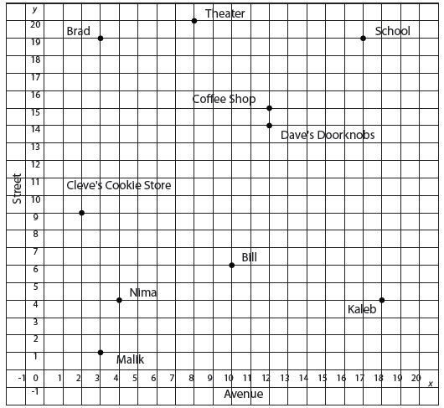

1. Luis works at a theater on 8th Avenue and 20th Street. Kaleb lives at the corner of 18th Avenue and 4th Street. What is a possible location that is midway between them?
2. Nima lives at the corner of 4th Avenue and 4th Street. Bill lives at the corner of 10th Avenue and 6th Street. Their favorite bakery is in a spot where it partitions the line into a ratio of 2:3. Find the location of their bakery.
3. How far is Cleve’s Cookie Store from the Coffee shop?

Use the map and the information given to solve each problem that follows.



1. Brad and Malik both believe they live closest to the cookie store. State who is correct and find how much closer that person lives.
2. The main entrance to the high school is located at the corner of 17th Avenue and 19th Street. On his directed walk from the school to the coffee shop that is located at 12th Avenue and 15th Street, he stops at a bank to take out money to buy his coffee. The bank partitioned his walk into a ratio of 2:1, find the location of the bank.
3. Explain how you could tell whether a problem should be solved using Pythagorean Theorem or Triangle Sum Theorem.

Solve the following by using Pythagorean Theorem or Triangle Sum Theorem

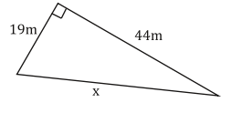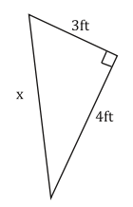

1. 12.

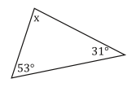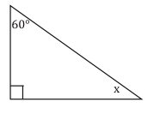

1. 14.

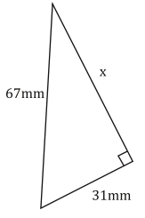

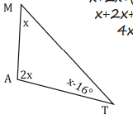

1. 16.

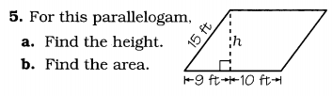



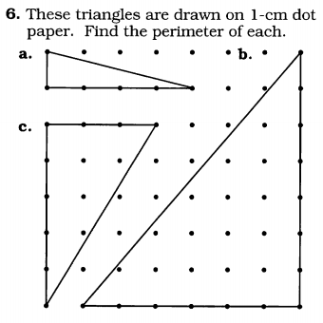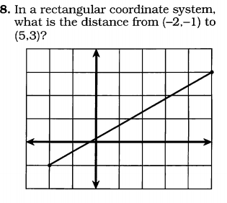

1. Given line AC is three times as long as BC solve for X. AC=30 BC=5x-10

A

B

C

1. Given line AC is 5 times as long as BC solve for X. AC=60 BC=5(2+5x)

A

B

C

1. Given AC is three times as long as BC solve for X. AC=30 BC=X+7

A

B

C

1. Given AC is twice as long as BC solve for X. AC=24 BC=x+3

A

B

C

1. Given AC is five times as long as BC solve for X. AC=25 BC=x+4
2. Given AC is four times as long as BC solve for X. AC=36 BC=3x-6
3. Given AC is twice as long as BC solve for X. AC=16 BC=2x-14
4. Write out the steps for a line copy.
5. Copy the following line.
6. Create a line 3 times the length of the given line.

For the following problems, name the type of angles, and solve for the missing angle measure.

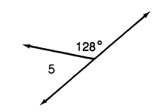

x

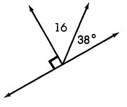

x

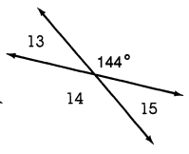

x

2. Write the steps for an angle copy.
3. Copy the following angle.

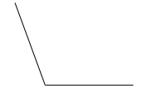

1. Create an angle 2 times the measure of the given angle.

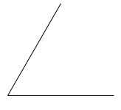

For the following diagrams. Set up an equation to solve for x. Write a justification for your equation.

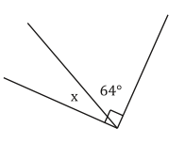

1.

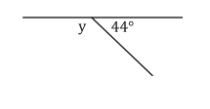

2.

4.

3.

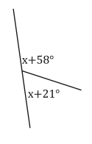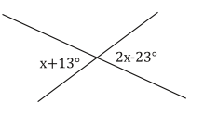

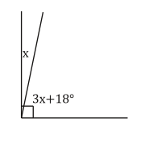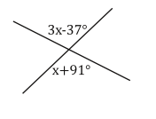

7.

6.

5.

