Name: ___________________________________________________ Date: ________
Unit 1 Cumulative Review #2
*Practice Test*
- Othello owns a corn field and has placed fences around four poles, A, B, C, and D that mark the edges of the field. He needs to drive around the field every day to check whether anybody has tried to break in. The four poles are located at: $A\left(1,-3\right)$, $B(8, 0)$, $C(9,4)$ and $D\left(2, 1\right)$. How many miles will Othello drive if he starts at pole A and drives around the entire border of the field.
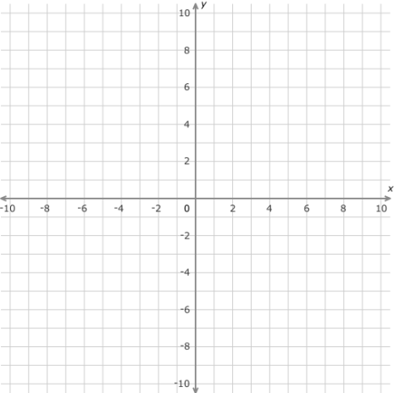

- Jessica lives at the corner of 7th Avenue and 19th Street. She decides to walk from her house to the coffee shop that is located at 12th Avenue and 15th Street, she stops at her bank to take out money to buy her coffee. The bank partitioned her walk into a ratio of 3:1, find the location of the bank.

- Tyger has a rectangular garden measuring 12m by 20 m that he wants to split diagonally from corner to corner using a fence. How long does his fence need to be?
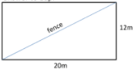

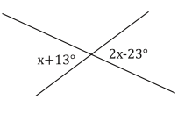
- Type of problem: _______________
Set up an equation and solve for x.

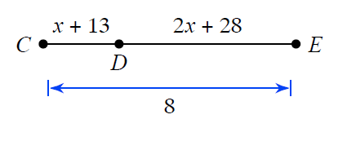

- Type of problem: _______________
Set up an equation and solve for x.

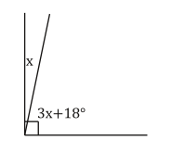

- Type of problem: _______________
Set up an equation and solve for x.

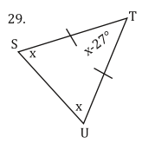

- Type of problem: _______________
Set up an equation and solve for x.

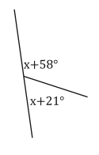

- Type of problem: _______________
Set up an equation and solve for x.

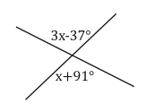

- Type of problem: _______________
Set up an equation and solve for x.

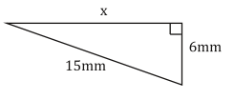

- Type of problem: _______________
Set up an equation and solve for x.

