Name: ___________________________________________ Date: ______________
Unit 3 Quiz Review
- In the diagram $\overset{⃡}{FG}⊥\overset{⃡}{GH}$. Find the value of x.
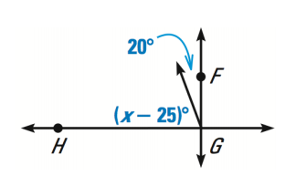

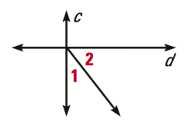
- What statement must be true if $c⊥d$ ?
  - $m∠1+m∠2=90°$
  - $m∠1+m∠2<90°$
  - $m∠1+m∠2>90$
  - Cannot be determined

Answer the following questions using the diagram below:
- Name all sets of complementary angles:
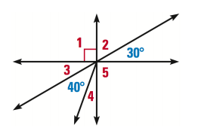
6
7

- Name all pairs of vertical angles:

- Given $m∠6=30°$and $m∠7=40°$ find
all missing angle measures.

- What information would be enough to prove two lines are perpendicular to each other? (3)

- What information would be enough to prove two lines are parallel? (4)
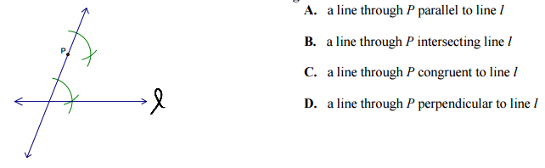
- Nicole is working on the following construction with her compass and straightedge. Which best describes the construction that Nicole is doing?

- Complete the construction in #7 by drawing in the last step.

- Milon is working on the following construction with his compass and straightedge. What is he constructing?
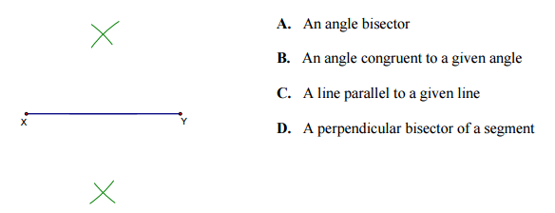

- Complete the construction in #9 by drawing in the last step.

- Javion is working on the following construction with his compass and straightedge. What is he constructing?
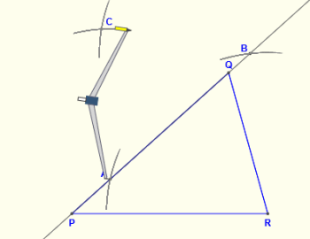
- A perpendicular bisector.
- An angle bisector.
- An altitude
- A line parallel to line $\overline{PQ}$

- Complete the construction in #11 by drawing the last step.
- $y=\frac{1}{4}x+8$
- $y=-\frac{1}{2}x-2.4$
- $y=\frac{5}{7}x-5$
- $y=-\frac{3}{5}x+94$
- $y=-4x-0.2$
- $y=x+1$
- $y=-\frac{1}{2}x$
- $y=x-3$
- $y=-\frac{7}{5}x+4.5$
- $y=\frac{3}{5}x-11$

Use the lines given above to answer the following questions:

- Which pairs of lines are parallel?

- Which pairs of lines are perpendicular?

- Name at least one pair of intersecting lines:

- Parallel lines have _______________________________________ slopes.
- What is the slope of the line $y=\frac{5}{7}x-12$?
- Write the equation of a line parallel to $y=2x$.
- Perpendicular lines have _______________________________________ slopes.
- What is the slope of the line $y=5x+3$?
- Write the equation of a line perpendicular to $y=-8x+3$.

