Name: ________________________________________________ Date: ________
Unit 3 Test Review
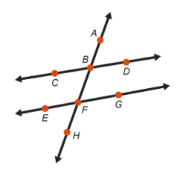
- Nicole constructed two lines cut by a transversal. She wants to verify that $\overline{CD}$ and $\overline{EG}$ are parallel. Which statement would prove that $\overline{CD}$ and $\overline{EG}$ are parallel?

  - $∠CBF$ and $∠FBD$ are supplementary.
  - $∠ABD$ and $∠BFE$ are congruent.
  - $∠CBF$ and $∠BFG$ are congruent.
  - $∠CBF$ and $∠ABD$ are congruent.

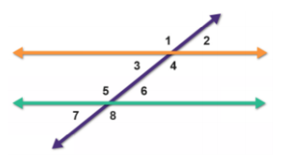
Use the diagram below to answer questions 2 & 3.

- The diagram shows two parallel lines cut by a transversal. Fill in the blanks to complete the statements.
In the diagram, there are two parallel lines intersected by a transversal.
- Angles 3 and ____________________________ are consecutive interior angles.
- Because $∠7$ is a corresponding angle to $∠$_______________ and because $∠7$ forms a linear pair with $∠5$ we know $m∠5+m∠3=$_______________.

- The diagram shows two parallel lines cut by a transversal. Fill in the blanks to complete the statements below.
- In the diagram, $∠3$ and $∠6$ are ________________________ interior angles.
- Because angle 6 is a corresponding angle with $∠$_______________,
- You can use the transitive property to show that $∠3$ and $∠6$ are ___________________ .
- Given Line S II R. Pick a theorem and prove it.
2
1
4
3
5
6
7
8
S
R

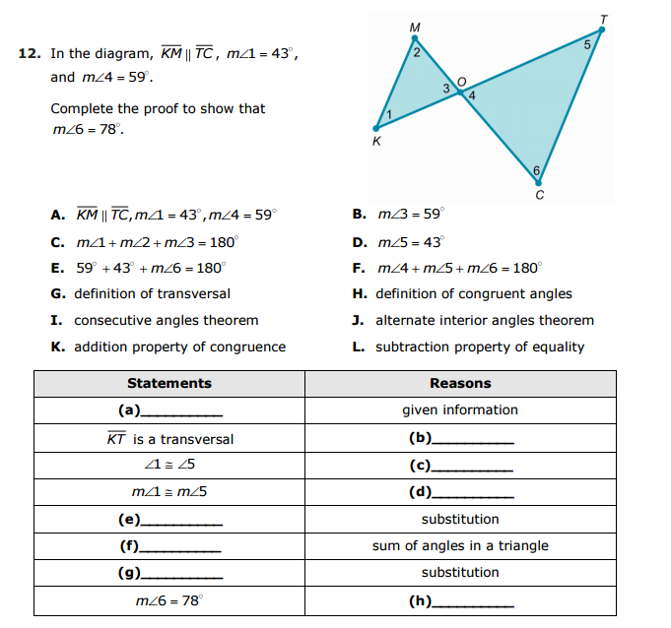
consecutive interior angles theorem

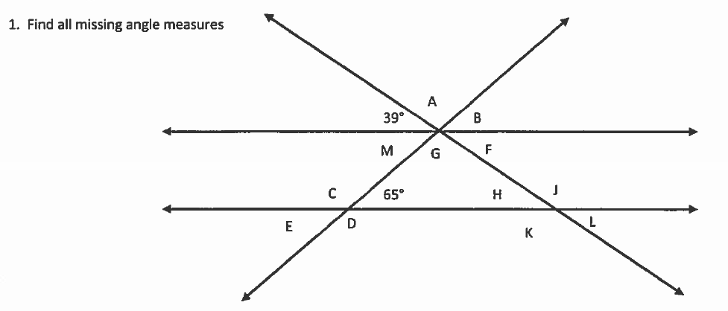
- Find all missing angle measures
42°
61°

- The figure in the diagram contains lines $m$ and $n$ and transversal line $k$.
Given $m∥n$ solve for x and justify your reasoning in a two-column proof.
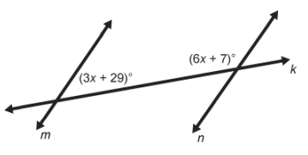

- What information would be enough to prove two lines are perpendicular to each other? (3)

- What information would be enough to prove two lines are parallel? (4)

For the following, write the name of the construction then solve for $x$.
- Construction: __________________ 11. Construction: __________________

$x=$__________________ $x=$__________________

Given: $∠APM=4x-18$
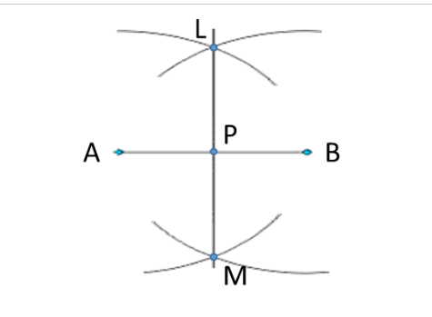
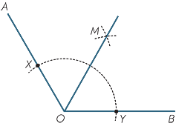
$$2x-43$$
$$x+14$$

- Complete the chart using the following diagram.
1
4
2
3
8
5
7
6
S
R

Angle Type | Example | Congruent or Supplementary | Does it have a converse?
Vertical Angles
Linear Pair
Alternate Interior
Consecutive Interior
Alternate Exterior
Corresponding

