UNIT 4 PRE TEST
- Which of these will most likely result in variation within a species
  - Mutation
  - Succession
  - Diffusion
  - Competition
- Coyotes and grey wolves have a high degree of relatedness. Which of these best describes why the two species are closely related?

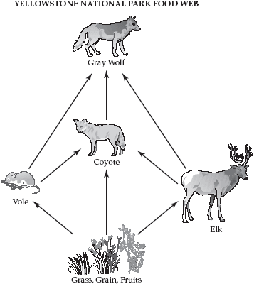
  - They have similar behaviors
  - They have a common ancestor
  - They feed on the same types of food
  - They are found in the same habitat
- Students conducted an experiment to test the effect of antibiotics on bacteria. They placed bacteria in a petri dish that contained agar treated with an antibiotic. Only one of the bacterial colonies survived.
Which of these statements best explains why only one colony survived?
  - The bacteria in the colonies competed for survival
  - There was only enough food in the dish for some bacteria to survive
  - There was not enough antibiotic in the dish to kill all the bacteria
  - The bacteria in the surviving colony had genetic variations that allowed them to survive
- Amphibians were the first vertebrates to live on land. The ancestors of amphibians were probably lobe-finned fish. The diagram below shows this development of amphibians over time.
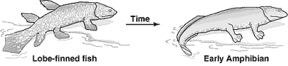
Which of these terms best describes how amphibians could have developed from lobe-finned fish?
- Selective breeding
- Cloning
- Migration
- Natural selection
- A cell is observed through a microscope. The cell is found to have a cell wall, a cell membrane, and numerous ribosomes. The cell does not have a nucleus. This cell is most likely from a
  - Bacterium
  - Fungus
  - Plant
  - Protest
- The desert climate is caused by geographic conditions such as location, high atmospheric pressure, and proximity of mountain ranges. Average desert rainfall amounts are usually less than 50 cm per year. Soil in deserts is coarse, sandy, and rocky. Desert plants and animals have specialized characteristics that help them survive in the harsh environment. An example is the Saguaro cactus. The Saguaro has a shallow root system with a main taproot and other roots that radiate out and collect surface water. The trunk of the Saguaro has the ability to expand while storing water. The sweet-nectar flowers of the Saguaro attract white-winged doves, bats, and other animals. These animals feed on the nectar. They are necessary for cross-pollination. Cross-pollination occurs when the pollen of a flower is carried to a flower on another plant. The illustration below shows the Saguaro cactus. Which advantage is the most likely result of cross-pollination to Saguaro cacti?
  - Disease resistance
  - Variation within species
  - Larger cacti offspring in each generation
  - Increased number of animals that drink nectar
- Crops must be able to compete with weeds in order to be successful. Certain crops have been genetically modified to be resistant to specific herbicides. In areas where these crops are grown, the herbicides can be sprayed to kill weeds without damaging the crops. However, weeds in these areas have begun to show resistance to the herbicides. The environmental pressure most likely responsible for an increase in the number of resistant weeds is
  - Herbicides
  - Nonresistant weeds
  - Competition with crops
  - Genes in genetically modified crops
- Prokaryotic cells possess all of the following except
  - Cell membrane
  - Ribosomes
  - Cell wall
  - Nuclear membrane
- Plants grow in various environments. Some plants, like mangroves, grow in salty wetlands. Mangroves have specialized structures that prevent salt from entering their cells. Other mangroves have specialized glands that can excrete excess salt.Glands that excrete salt in the mangroves are examples of
  - Meiosis
  - Osmosis
  - Adaptations
  - Successions
- An insecticide is a chemical that kills insects. Most insects are killed the first time they are exposed to an insecticide. However, some insects carry a gene that enables them to survive their first exposure to an insecticide. When these surviving insects reproduce, this gene may be inherited by their offspring. The number of insecticide-resistant insects usually increases over time because increasing numbers of offspring with this gene are able to survive and reproduce. Which process enables increasing numbers of insects to survive their initial exposure to an insecticide?
  - Cloning
  - Mutation
  - Natural selection
  - Genetic engineering
- A researcher is studying raccoons and skunks. She wants to find out how closely these two mammals are related. Which of these characteristics would be best for her to study?
  - Sequence of DNA
  - Reproductive habits
  - Movement of RNA
  - Physical appearance
- A 125-million-year-old small mammal skeleton was recently discovered in China. The role of this small mammal in its ecosystem can best be determined by comparing its skeleton to
  - Ancient small mammal skeleton
  - Modern small mammal skeleton
  - Modern small mammal DNA
  - Ancient small mammal DNA
- The figure below shows the skeletal structure of a seal's flipper and a monkey's arm.
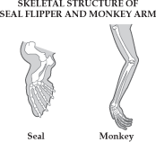
The skeletal structures of the flipper and the arm are similar, even though they have different functions. Seals use their flippers for swimming, while monkeys use their arms primarily for grasping and lifting. The seal's flipper and the monkey's arm differ in appearance. This difference is the result of
- Migration
- Genetic engineering
- Succession
- Natural selection
- Scientists have found many similarities in the proteins of turtles and sharks. These similarities suggest that turtles and sharks
  - Have stopped evolving
  - Have a common ancestor
  - have all the same DNA sequences
  - Have the same number of chromosomes
- Rafflesia flowers produce the smell of rotting flesh. This smell attracts flies. When the flies land on the flowers, the pollen attaches to them. The flies then transport the pollen to other flowers.
Producing a smell to attract flies is an example of
  - Parasitism
  - Adaptation
  - Replication
  - Predation
- Loggerhead turtles in the Atlantic Ocean return to lay their eggs on the same beaches where they hatched. Scientists have observed that the turtles have a “compass sense.” This sense allows them to use Earth's magnetic field to find their way back to the beaches where they were hatched.
Which of these terms best describes the turtle's ability to use Earth's magnetic field?
  - Diversity
  - Habitat
  - Succession
  - Adaptation
- Which of these is not a use for DNA fingerprinting
  - To determine how individuals are related
  - To make messenger RNA
  - To determine a genetic sequence
  - To study inherited diseases
- When lions prey on a herd of antelopes, some antelopes are killed and some escape to live and reproduce. Which of these best describes this situation
  - An individual passes along acquired characteristics to the next generation
  - Natural selection is a random process
  - Individuals that function best tend to leave the most offspring
  - Species remain unchanged throughout time
- Two animals of difference species would be least likely to
  - Produce fertile offspring
  - Have similar body structures
  - Consume the same food
  - Live successfully in the same habitat
- Natural selection could not occur without these processes
  - Cloning
  - Mitosis
  - Genetic engineering
  - Asexual reproduction

