Name: __________________________________________________ Date: _______

Unit 4 Test Review

- Given: $\overline{CD}$is a perpendicular bisector.
Prove: $∠ACD≅∠BCD$
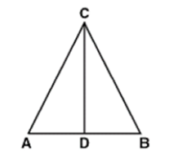

- Given: ∠QPR≅∠SPR
∠RQP≅∠RSP
Prove: $\overline{PQ}≅\overline{PS}$
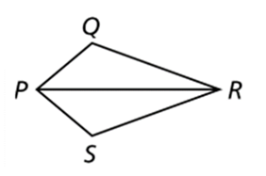

- Given: $\overline{FS}$bisects ∠TFR
∠T≅∠R
Prove: ∆FTS≅∆FRS

- Given: O is the midpoint of $\overline{MP}$
∠NMO≅∠QPO
Prove: $∆NOM$≅$∆QOP$
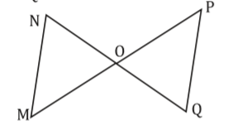

- Given: $\overline{AD}$ is the median of $∆CAB$
$∠ADC≅∠ADB$
Prove: One of the two properties of isosceles triangles.
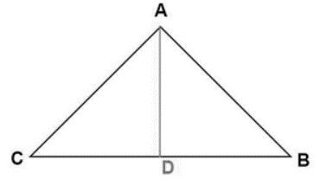

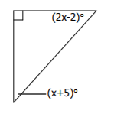
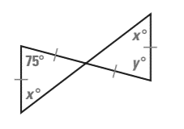
- 7.

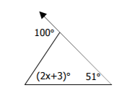
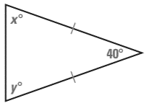
- 9.

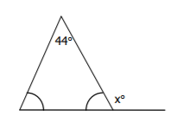
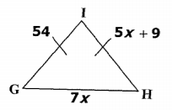

- 11.

